**CampusPass**

A RFID Attendance based system using Raspberry pi zero w

**Capstone Project Report**

**END-SEMESTER EVALUATION**

**Submitted by:**

(102003316) Manvi Verma

(102053018) Namay Gupta

(102003024) Prajwal Sadotra

(102196012) Sanya Aggarwal

(102183026) Sparsh Lamba

**BE Final Year - COE/CSE**

**CPG No.: 189**

**Under the Mentorship of**

Dr. Shruti Aggarwal

Department of CSED, TIET



**Computer Science and Engineering Department**

**Thapar Institute of Engineering and Technology, Patiala**

**December 2023**

**ABSTRACT**

This project introduces an innovative RFID-based card system designed to redefine and enhance campus services for students, faculty, and staff. Leveraging the power of Radio Frequency Identification (RFID) technology, the system establishes a sophisticated wireless communication framework, seamlessly integrating features such as identification, attendance tracking, payment processing, and access control. The cornerstone of this system lies in the deployment of smart cards equipped with RFID capabilities. These cards not only enable swift entry to campus facilities, thereby significantly reducing waiting times and increasing overall convenience, but also serve as a comprehensive solution for multiple functionalities. The automated attendance tracking feature not only enhances accuracy but also alleviates the administrative burden associated with manual tracking methods, providing a more reliable assessment of student engagement. Security is a paramount concern addressed by this system, incorporating robust encryption and authentication protocols. These measures are implemented to mitigate the risks of unauthorized access, ensuring that campus facilities remain secure and accessible only to authorized individuals. Furthermore, the RFID-enabled smart cards contribute to an efficient and streamlined campus experience by facilitating cashless transactions at various points throughout the campus. This not only simplifies payment processes but also adds an extra layer of convenience for students, faculty, and staff. In essence, this RFID-based card system represents a comprehensive solution for optimizing campus services, blending technological sophistication with practical benefits, and prioritizing efficiency, security, and convenience in equal measure.

**DECLARATION**

We hereby declare that the design principles and working prototype model of the project entitled CampusPass is an authentic record of our own work carried out in the Computer Science and Engineering Department, TIET, Patiala, under the guidance of Dr. Shruti Aggarwal during 7th Semester (2023).

Date: 15-December-2023

|  |  |  |
| --- | --- | --- |
| **Roll No.** | **Name** | **Signature** |
| 102003316 | Manvi Verma |  |
| 102053018 | Namay Gupta |  |
| 102003024 | Prajwal Sadotra |  |
| 102196012 | Sanya Aggarwal |  |
| 102183026 | Sparsh Lamba |  |

*Counter Signed By:*

Mentor: Dr. Shruti Aggarwal

Designation: Assistant Professor

Computer Science & Engineering Department

TIET, Patiala

**ACKNOWLEDGMENT**

We would like to express our thanks to our mentor Dr. Shruti Aggarwal. She has been of great help in our venture, and an indispensable resource of technical knowledge. She is truly an amazing mentor to have. We are also thankful to Dr. Shalini Batra, Head, Computer Science and Engineering Department, entire faculty and staff of Computer Science and Engineering Department, and also our friends who devoted their valuable time and helped us in all possible ways towards successful completion of this project. We thank all those who have contributed either directly or indirectly towards this project. Lastly, we would also like to thank our families for their unyielding love and encouragement. They always wanted the best for us and we admire their determination and sacrifice.

Date: 15 December, 2023

|  |  |  |
| --- | --- | --- |
| **Roll no.** | **Name** | **Signature** |
| 102003316 | Manvi Verma |  |
| 102053018 | Namay Gupta |  |
| 102003024 | Prajwal Sadotra |  |
| 102196012 | Sanya Aggarwal |  |
| 102183026 | Sparsh Lamba |  |

**TABLE OF CONTENTS**

**ABSTRACT…………………………………………………….…………………………….i**

**DECLARATION………………………………………………….…………………………ii**

**ACKNOWLEDGEMENT………………………………….................................................iii**

**LIST OF FIGURES…………………………………………………………………………iv**

**LIST OF TABLES…………………………………………….……………………………..v**

**LIST OF ABBREVIATIONS…………………………………..…………………………...vi**

**CHAPTER………………….…………………………………………..……………Page No.**

**1- INTRODUCTION**

1.1 Project Overview 1

1.1.1 Technical terminology 2

1.1.2 Problem statement 3

1.1.3 Goal 3

1.1.4 Solution 3

1.2 Need Analysis 4

1.3 Research Gaps 4

1.4 Problem Definition and Scope 5

1.5 Assumptions and Constraints 6

1.6 Standards 7

1.7 Objectives (Approved by Mentor/Panel) 9

1.8 Methodology Used 9

1.9 Project Outcomes and Deliverables 10

1.10 Novelty of Work 10

**2 - REQUIREMENT ANALYSIS**

2.1 Literature Survey 12

2.1.1 Related Work 12

2.1.2 Research Gaps of Existing Literature 16

2.1.3 Detailed Problem Analysis 17

2.1.4 Survey of Tools and Technologies Used 18

2.1.5 Summary 19

2.2 Software Requirements Specification 20

2.2.1 Introduction 20

2.2.1.1 Purpose 20

2.2.1.2 Intended Audience and Reading Suggestions 21

2.2.1.3 Project Scope 22

2.2.2 Overall Description 22

2.2.2.1 Product Perspective 22

2.2.2.2 Product Features 23

2.2.3 External Interface Requirements 23

2.2.3.1 User Interfaces 23

2.2.3.2 Hardware Interfaces 24

2.2.3.3 Software Interfaces 24

2.2.4 Other Non-functional Requirements 25

2.2.4.1 Performance Requirements 25

2.2.4.2 Safety Requirements 25

2.2.4.3 Security Requirements 26

2.3 Cost Analysis 26

2.4 Risk Analysis 27

**3 -METHODOLOGY ADOPTED**

3.1 Investigative Techniques 30

3.2 Proposed Solution 30

3.3 Work Breakdown Structure 31

3.4 Tools and Technologies Used 32

**4 -DESIGN SPECIFICATIONS**

4.1 System Architecture 34

4.2 Design Level Diagrams 35

4.3 User Interface Diagrams 35

**5 -IMPLEMENTATION AND EXPERIMENTAL RESULTS**

5.1 Experimental Setup 38

5.2 Experimental Analysis 39

5.2.1 Data 39

5.2.2 Performance Parameters 39

5.3 Working of the project 40

5.3.1 Procedural Workflow 40

5.3.2 Algorithmic Approaches Used 42

5.3.3 Project Deployment 48

5.3.4 System Screenshots 48

5.4 Testing Process

5.4.1 Test Plan 52

5.4.2 Features to be tested 52

5.4.3 Test Strategy 53

5.4.4 Test Techniques 53

5.4.5 Test Cases 55

5.4.6 Test Results 56

5.5 Results and Discussions 57

5.6 Inferences Drawn 58

5.7 Validation of Objectives 58

**6 -CONCLUSIONS AND FUTURE DIRECTIONS**

6.1 Conclusions 59

6.2 Environmental, Economic and Societal Benefits 59

6.3 Reflections 61

6.4 Future Work 61

**7 -PROJECT METRICS**

7.1 Challenges Faced 63

7.2 Relevant Subjects 63

7.3 Interdisciplinary Knowledge Sharing 64

7.4 Peer Assessment Matrix 65

7.5 Role Playing and Work Schedule 65

7.6 Student Outcomes Description and Performance Indicators 66

7.7 Brief Analytical Assessment 67

**APPENDIX A: REFERENCES**

**APPENDIX B: PLAGIARISM REPORT**

**LIST OF FIGURES**

|  |  |  |
| --- | --- | --- |
| Figure No | Caption page | Page No |
| Figure 1.1 | A RFID card | 1 |
| Figure 1.2 | A RFID Card Reader | 1 |
| Figure 2.1 | Blackboard Attendance System | 13 |
| Figure 2.2 | Elucian Banner System using RFID | 13 |
| Figure 2.3 | Amano McGann System for Parking | 14 |
| Figure 3 | Gantt Chart of Work Breakdown structure | 32 |
| Figure 4.1 | System Architecture | 34 |
| Figure 4.2 | Design Level Diagram | 35 |
| Figure 4.3 | ER Diagram | 35 |
| Figure 4.4 | Block Diagram | 36 |
| Figure 4.5 | Activity Diagram | 37 |
| Figure 5.1 | Experimental Setup | 39 |
| Figure 5.2 | Procedural Workflow of Attendance Tracking System | 41 |
| Figure 5.3 | Procedural Workflow of Access Control | 42 |
| Figure 6.4.1 | Hardware Circuits | 49 |
| Figure 6.4.2 | Raspberry pie zero w and circuits | 49 |
| Figure 6.4.3 | The Login Page | 50 |
| Figure 6.4.4 | Select Operation | 50 |
| Figure 6.4.5 | The Attendance Page | 51 |
| Figure 6.4.6 | The Payment Page | 51 |
| Figure 6.4.7 | The Access Control Page | 51 |
| Figure 7 | Graph of Accuracy vs Users | 57 |
| Figure 8 | Work Schedule | 66 |

**LIST OF TABLES**

|  |  |  |
| --- | --- | --- |
| Table No | Caption | Page No |
| Table 1 | Assumptions and Constraints | 6 |
| Table 2 | Literature Review and its Findings | 12 |
| Table 3 | Cost Analysis | 26 |
| Table 4 | Risk Analysis | 27 |
| Table 5 | Design Diagrams Description | 33 |
| Table 6 | Test Cases | 55 |
| Table 7 | Confusion Matrix | 57 |
| Table 8 | Validation of Objectives | 58 |
| Table 9 | Peer Assessment Matrix | 65 |
| Table 10 | Role Playing | 65 |
| Table 11 | Student Outcomes Description and Performance Indicators | 66 |

**LIST OF ABBREVIATIONS**

|  |  |
| --- | --- |
| **RFID** | Radio-frequency Identification |
| **ISO** | International Organization for Standardization |
| **IEC** | International Electrotechnical Commission |
| **IoT** | Internet of Things |
| **AI** | Artificial Intelligence |
| **SQL** | Structured Query Language |
| **ERP** | Enterprise Resource Planning |
| **RDBMS** | Relational Database Management System |
| **AWS** | Amazon Web Services |
| **SRS** | Software Requirements Specification |
| **UI/UX** | User Interface/User Experience |
| **GDPR** | General Data Protection Regulation |
| **TAM** | Technology Acceptance Model |
| **SIS** | Student Information Systems |
| **CPU** | Central Processing Unit |
| **IT** | Information Technology |
| **APIs** | Application Programming Interfaces |
| **NFC** | Near Field Communication |
| **GPS** | Global Positioning System |

**INTRODUCTION**

* 1. **Project Overview**

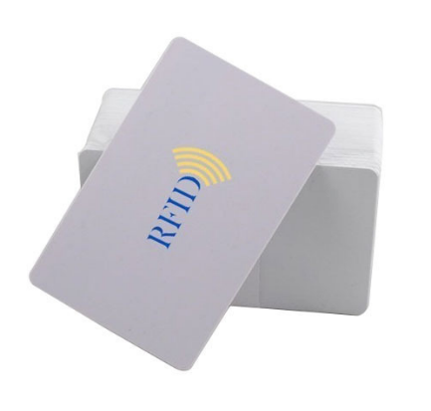The RFID card system project is a comprehensive and innovative project aimed at providing a seamless and secure way for students, faculty, and staff to access various services on campus. The project involves the use of Radio Frequency Identification (RFID) technology, which is a wireless communication technology that allows for the identification and tracking of objects using radio waves. The primary objective of the project is to improve attendance tracking, payment processing, and access control within the college campus. This will ensure that students, faculty, and staff can efficiently and effectively access services and facilities on campus while enhancing security and reducing administrative workload. The RFID card system project involves several components, including RFID cards, RFID readers, attendance tracking, payments, access control, integration with existing systems, and user experience.

1. RFID Cards: The system will use RFID cards that are assigned to students, faculty, and staff. These cards will contain a unique identifier that is linked to the user's profile in the system. The cards will be used for attendance tracking, payment processing, and access control. The card are durable, lightweight, and easy to carry around.

Figure 1.1 A RFID Card

1. 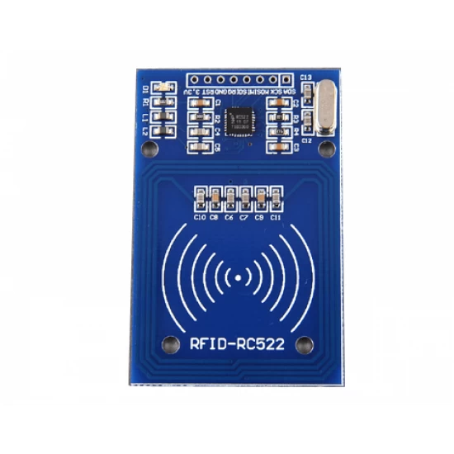RFID Readers: The system will use RFID readers that are installed in classrooms, shops, e-rickshaws, and other locations on campus. These readers will be used to read the unique identifier on the RFID cards, allowing for attendance tracking, payment processing, and access control. The readers are durable and reliable and can be installed in various locations on campus.

Figure 1.2 A RFID Card Reader

1. Attendance Tracking: The system will be used to track attendance in classrooms and other campus events. Students will be required to swipe their RFID cards to record their attendance. The data will be automatically updated in a centralized database, allowing professors and administrators to track attendance in real-time and make informed decisions based on attendance patterns. Additionally, the implementation of RFID-based attendance systems can also enhance the security of educational institutions by accurately monitoring the entry and exit of students.
2. Payments: The system will be used to facilitate cashless payments within the campus. Students will be able to make payments at various shops and services on campus by simply swiping their RFID cards. This will eliminate the need for carrying cash or credit cards, providing a secure and efficient way to make payments. The system will also allow students to view their payment history and identify areas where they need to manage their expenses.
3. Access Control: The system will be used to provide access control to various areas of the campus. Authorized personnel will be able to swipe their RFID cards to gain access to restricted areas, such as laboratories, libraries, and faculty offices. This will ensure the security and safety of the campus and its occupants. The system will also allow administrators to manage access control permissions and view access logs for security purposes.
4. Integration with Existing Systems: The RFID card system will be integrated with existing systems, such as student information systems, financial systems, and security systems. This will ensure that the RFID card system works seamlessly with the existing infrastructure and processes on campus, reducing the need for redundant data entry. The integration will also enhance data accuracy and reduce the workload on administrative staff.
5. User Experience: The system will be designed with the user experience in mind. The system will have an intuitive user interface that is easy to use and navigate. It will be optimized for mobile devices and allow users to access their attendance records, payment history, and access control permissions from a single platform. The system will also provide user-friendly feedback and notifications to enhance the user experience.

In conclusion, the RFID card system project is an ambitious project that will revolutionize the way students, faculty, and staff access services on campus. The project will leverage RFID technology to provide a secure, efficient, and convenient way for users to track attendance, make payments, and gain access to restricted areas on campus. The project will be integrated with existing systems and will be designed with the user experience in mind.

* + 1. **Technical Terminology**

Leveraging the compact processing power of the Raspberry Pi Zero W and the versatility of RFID technology, this system streamlines attendance tracking, cashless payments, and access control within a unified platform. By employing RFID tags and readers, automated attendance marking occurs, synchronizing with a real-time database for immediate record updates. The same RFID infrastructure seamlessly integrates payment functionality, eliminating the need for cash and relying solely on tagged cards for secure transactions. Access control is further bolstered by leveraging the existing RFID circuits, effectively restricting unauthorized entries and enhancing security protocols. This cohesive design translates to an efficient and robust system, optimizing data accuracy, financial transactions, and physical access control within a single, streamlined framework.

* + 1. **Problem Statement**

The existing methods of attendance tracking, payment processing, and access control within the college present significant challenges. Manual or semi-manual attendance tracking methods, such as using attendance sheets or biometric scanners, are prone to errors, particularly in large classes or simultaneous sessions. Additionally, monitoring attendance in non-classroom areas like labs poses logistical challenges and may necessitate additional resources.

The current cash-based payment system in the college is inconvenient and poses security risks for both students and faculty. Carrying cash for purchases and handling large amounts of cash at on-campus vendors increases the likelihood of theft. Tracking and managing cash transactions also present challenges, leading to potential accounting discrepancies.

Access control, managed through physical keys, swipe cards, or stationed security personnel, is cumbersome and may not effectively prevent unauthorized access. Lost or duplicated keys, shared or stolen swipe cards, and limited monitoring capabilities of security personnel contribute to security vulnerabilities. Restricted areas, such as labs or equipment rooms, pose additional challenges in managing access and may require additional resources for effective monitoring.

* + 1. **Goal**

The primary goal of this project is to address the inefficiencies and security concerns associated with the current campus services. The aim is to implement an RFID-based card system that leverages wireless communication for seamless identification, attendance tracking, payment processing, and access control. The goal is to enhance overall efficiency, security, and convenience for students, faculty, and staff within the campus environment.

* + 1. **Solution**

The proposed solution involves the implementation of an innovative RFID-based card system. This system will redefine campus services by providing swift entry to facilities, reducing waiting times, and increasing overall convenience. The smart cards will enable automated attendance tracking, ensuring quicker and more accurate records for professors and staff. Additionally, the system will streamline payment processes at on-campus vendors, making transactions easy, secure, and contactless.

Enhanced access control and security will be achieved through the implementation of encryption and authentication protocols on RFID-enabled cards, mitigating unauthorized access risks. The overall objective is to create a comprehensive solution that not only addresses the identified problems of attendance tracking, payment systems, and access control but also contributes to a reduction in operational costs for the college. The implementation of this system is expected to optimize administrative tasks, allowing for the reallocation of resources to other strategic initiatives.

* 1. **Need Analysis**

1. Efficient attendance tracking: Traditional methods of attendance tracking, such as paper sign-in sheets, can be time-consuming and inefficient, leading to errors and inaccuracies. The RFID card system provides a more efficient and accurate method of tracking attendance, allowing faculty to focus on teaching rather than administrative tasks.
2. Convenient payment processing: On-campus shops and facilities typically require students to carry cash or credit cards to make purchases. However, students may not always have cash or cards on hand. The RFID card system allows students to make purchases using their ID cards, providing a more convenient and secure payment method.
3. Enhanced campus security: A critical concern for colleges and universities, particularly considering recent incidents of violence and other security threats. The RFID card system allows only authorized personnel to enter secure areas such as dormitories and labs.

Overall, the RFID card system addresses several needs within the college community, providing a more efficient, convenient, and secure method of attendance tracking, payment processing, and access control.

* 1. **Research Gaps**

The RFID card system project seeks to revolutionize attendance tracking, payment processing, and access control across the college campus. However, amidst its ambitious goals, several research gaps beckon exploration for enhanced system efficacy and efficiency. Firstly, delving into user adoption and behavior is crucial, deciphering factors influencing their acceptance of the RFID card system, gauging resistance to change, preferred card types, and how user actions impact system utilization.

Equally pressing is the domain of data privacy and security, warranting further investigation into RFID technology vulnerabilities, potential security threats encompassing data breaches and card cloning, and the establishment of robust encryption protocols to safeguard sensitive information. The intricate task of seamlessly integrating the RFID card system with existing campus systems necessitates a dedicated research effort to address challenges and devise solutions concerning student information systems, financial databases, and access control systems.

To mitigate power concerns, particularly in remote or outdoor settings, in-depth inquiry into energy-efficient RFID reader solutions and alternative power sources is warranted. Exploring the fusion of multi-factor authentication techniques like biometrics or one-time passwords with the RFID card system holds potential for bolstering security and deterring unauthorized access.

Moreover, the application of real-time data analytics to RFID-generated data stands as an untapped arena, offering insights into optimized attendance tracking and payment processing, driving informed decision making and resource allocation on campus. The perpetual quest for an enhanced user experience urges research aimed at identifying user pain points, refining the user interface, and perpetually elevating the RFID card system's usability.

In parallel, durability assessment of RFID cards, especially in harsh environments, emerges as an imperative, ensuring their longevity and functionality over an extended timeline. Complementing this, a comprehensive cost-benefit analysis is imperative, scrutinizing the economic impact of RFID card system implementation, encompassing initial investment, maintenance costs, and potential operational efficiencies.

Lastly, the bedrock of user feedback and satisfaction remains pivotal, necessitating the collection and analysis of user insights to catalyze iterative system improvements and updates.

* 1. **Problem Definition and Scope**

1. Attendance tracking: The current method of attendance tracking in the college may be manual or semi-manual, such as taking attendance sheets or using biometric scanners. These methods can be time-consuming and error-prone, especially in large classes or when multiple classes are held at the same time. The college may also face difficulties in tracking attendance in areas outside the classroom, such as labs or other facilities, which may require additional resources to monitor attendance.
2. Payment system: The current method of payment in the college may be cash-based, which can be inconvenient and pose security risks. Students and faculty members may have to carry cash with them to make purchases, and vendors may have to handle large amounts of cash, increasing the risk of theft. Additionally, the college may face difficulties in tracking and managing cash-based transactions, which can lead to accounting discrepancies.
3. Access control: The current method of access control in the college may involve physical keys, swipe cards, or security personnel stationed at entry points. These methods can be cumbersome and may not be effective in preventing unauthorized access. For example, keys can be lost or duplicated, swipe cards can be shared or stolen, and security personnel may not be able to monitor every entry point at all times. The college may also face difficulties in managing access to restricted areas, such as labs or equipment rooms, which may require additional resources to monitor access.
   1. **Assumptions and Constraints**

Table 1: Assumptions and Constraints for RFID bases attendance tracking, payments and access control.

|  |  |
| --- | --- |
| Assumptions:   1. RFID Card Availability: It is assumed that all students, faculty, and staff members will be issued RFID cards upon enrolment or joining the institution, and these cards will be the primary means of accessing campus services. 2. RFID Reader Deployment: Sufficient RFID readers will be strategically installed at key locations on campus, including building entrances, classrooms, libraries, laboratories, and other relevant areas, to ensure comprehensive coverage. 3. RFID Technology Compatibility: The existing infrastructure and systems on the campus can be integrated with RFID technology smoothly, allowing for seamless communication between the RFID card system and the pre-existing databases. 4. User Adoption: It is assumed that the majority of the campus population will embrace and adopt the RFID card system, ensuring high usage and acceptance rates among students, faculty, and staff. 5. Security Measures: The RFID card system will be designed with robust security features to prevent unauthorized access, data breaches, and card cloning. It is assumed that these security measures will be effective in protecting sensitive information. 6. RFID Card Maintenance: Users will be responsible for the proper care and maintenance of their RFID cards to ensure their longevity and functionality. | Constraints:   1. Budgetary Constraints: The RFID card system project will be subject to budget limitations, which may impact the scale and scope of implementation, the number of RFID readers deployed, and the level of integration and existing systems. 2. Technical Expertise: The availability of skilled technical personnel, both during the implementation phase and for ongoing maintenance, may be a constraint in the successful deployment and smooth operation of the RFID card system. 3. Interoperability Issues: The integration of the RFID card system with existing campus systems and databases may encounter compatibility issues, potentially leading to delays or additional development efforts. 4. Infrastructure Limitations: The physical infrastructure on the campus may pose challenges for deploying RFID readers in certain areas, such as remote buildings or outdoor spaces, requiring creative solutions or additional investments. 5. Privacy and Data Protection Regulations: The project must comply with relevant privacy laws and data protection regulations, which may impose certain limitations on data collection, storage, and usage. 6. Power Supply: The RFID readers will require a stable power supply for continuous operation. Ensuring an uninterrupted power supply in all locations may be a constraint, particularly in areas prone to power outages. 7. Initial Disruption: Implementing the RFID card system may cause temporary disruptions in existing campus services during the transition phase, requiring careful planning and communication to mitigate any negative impact. 8. Card Loss or Damage: In the event of a lost or damaged RFID card, a reliable process for card replacement must be established to avoid service disruptions for affected users. |

Addressing these assumptions and constraints effectively will be crucial for the successful deployment and operation of the RFID card system project, ensuring that it meets its primary objective of improving attendance tracking, payment processing, and access control on campus.

* 1. **Standards**

To ensure the successful implementation of the RFID card system project and achieve the stated objectives of improving attendance tracking, payment processing, and access control within the college campus, the following standards should be established:

1. RFID Technology Standards:
2. ISO/IEC 14443: Standard for proximity cards used in RFID systems, ensuring compatibility and interoperability with existing RFID technologies.
3. ISO/IEC 18000-6: Standard for air interface and communications protocols, facilitating seamless communication between RFID cards and readers.
4. Data Security Standards:
5. ISO/IEC 27001: Information Security Management System (ISMS) standard, ensuring that the RFID card system adheres to industry best practices for data security and privacy.
6. Encryption Standards: Implementing strong encryption algorithms (e.g., AES) to protect sensitive data stored on RFID cards and transmitted between readers and databases.
7. Attendance Tracking Standards:
8. Automated Attendance Recording: The system should automatically record and store attendance data in a secure centralized database, minimizing manual intervention.
9. Accuracy and Reliability: The RFID card system should achieve high accuracy and reliability in tracking attendance to prevent errors and improve data integrity.
10. Payment Processing Standards:
11. PCI DSS Compliance: If the RFID card system handles payment processing, it must comply with Payment Card Industry Data Security Standard (PCI DSS) requirements to protect cardholder data.
12. Payment Gateway Integration: Integrating with reputable and secure payment gateways to process transactions securely.
13. Access Control Standards:
14. Role-Based Access Control (RBAC): Implementing RBAC to ensure that users are granted access based on their roles and responsibilities within the institution.
15. Access Logging: Recording access events and maintaining access logs to monitor and audit system usage for security purposes.
16. User Experience Standards:
17. Intuitive User Interface: Designing a user-friendly interface for RFID card registration, access request, and payment processes to enhance user experience.
18. Accessibility: Ensuring that the system is accessible to all users, including those with disabilities, in compliance with relevant accessibility standards (e.g., WCAG).
19. Integration Standards:
20. API Standards: If integrating the RFID card system with existing campus systems, adhering to standardized APIs (e.g., RESTful APIs) to facilitate smooth data exchange.
21. Data Consistency: Ensuring data consistency and integrity between the RFID card system and other integrated systems.
22. Maintenance and Support Standards:
23. Service Level Agreements (SLAs): Defining SLAs for system maintenance, support response times, and issue resolution to maintain the system's reliability and availability.
24. Regular Updates and Patches: Keeping the system up-to-date with the latest software updates and security patches to address vulnerabilities and improve performance.

By establishing and adhering to these standards, the RFID card system project can achieve its objectives efficiently, securely, and with a high level of user satisfaction.

* 1. **Objectives**

The objective of our project is to build a RFID based card system that can be used for attendance tracking, payments, and access control within a college or university setting. The RFID card system will be designed to achieve following functionalities:

* Implement automated attendance tracking
* Design cashless payment system
* Develop secure access control system
  1. **Methodology Used**
* The scope of the project will be defined by the team, including the primary objectives, deliverables, and timelines. This will ensure that a clear roadmap is created for the project and that everyone on the team is on the same page.
* Requirements will be gathered by the team from stakeholders, including students, staff, and faculty, as well as vendors and other service providers. This will include requirements for the various features of the system, such as attendance tracking, payment processing, and access control.
* A detailed design plan for the system will be developed by the team based on the requirements gathered. This will include information about the hardware and software components, the user interface design, and the overall architecture of the system.
* The system will be built and tested by the team, including programming the necessary software, configuring the hardware, and integrating all the different components. The system will be tested thoroughly to ensure that it is functioning as intended and that all features are working properly.
* A pilot test will be conducted by the team with a small group of users to identify any potential issues or areas for improvement before rolling out the system to a wider audience.
* The system will be launched to a broader user base, accompanied by user training, ongoing support, and maintenance. The team will continuously monitor and enhance the system through surveys etc.
  1. **Project Outcomes and Deliverables**

1. Increase efficiency and accuracy of attendance tracking: The system should enable quicker and more accurate attendance tracking for professors and staff and reduce the likelihood of errors or inaccuracies in attendance records.
2. Streamline payment processing on campus: The system should enable easy, secure, and contactless payments at various on-campus vendors and service providers, such as shops, canteens, and e-rickshaws.
3. Enhance access control and security: The system should provide an effective and secure way to control access to various parts of the campus, such as dormitories, labs, and other restricted areas.
4. Reduce operational costs for the college: The system should reduce the need for manual attendance tracking, cash handling, and other administrative tasks, thereby reducing costs and freeing up resources for other initiatives.
   1. **Novelty of Work**

The novelty of the RFID card system project lies in its comprehensive approach to address multiple campus needs through the integration of RFID technology. Several aspects contribute to the novelty of this work:

1. Holistic Campus Solution: The RFID card system project aims to provide a holistic solution that encompasses attendance tracking, payment processing, and access control within the college campus. Combining these functionalities into a single integrated system is a novel approach that streamlines administrative processes and enhances user convenience.
2. Seamless User Experience: The project focuses on optimizing the user experience, making it seamless and user-friendly. By utilizing RFID cards for various campus services, students, faculty, and staff can access facilities and make payments with a single card, reducing the need for multiple identification methods.
3. RFID Technology Integration: The successful integration of RFID technology with existing campus systems and databases is a novel aspect of the project. This integration enables real-time data synchronization and facilitates a more efficient flow of information across different departments.
4. Enhanced Security: The RFID card system project prioritizes data security and privacy. The implementation of robust encryption protocols and security measures ensures protection against potential data breaches, unauthorized access, and card cloning attempts.
5. Scalability and Adaptability: The project addresses the challenge of scalability by designing a system that can accommodate a growing campus population and an increasing number of services and access points. Additionally, the system is adaptable to changing campus needs and can easily incorporate future technological advancements.
6. Energy-Efficient RFID Readers: To address power supply constraints, the project explores energy-efficient solutions for RFID readers, including the use of alternative power sources and standby modes, making it more environmentally friendly.
7. Cost-Effective Implementation: The RFID card system project involves a comprehensive cost-benefit analysis to assess the economic impact of implementation. This ensures that the project is not only innovative but also cost-effective for the institution in the long run.

**REQUIREMENT ANALYSIS**

**2.1 Literature Survey**

Table 2: The table on research findings for existing literature succinctly encapsulating key insights and discoveries derived from a comprehensive review of relevant academic works in the field.

Table 2: Literature Review and its Findings

|  |  |  |  |  |  |
| --- | --- | --- | --- | --- | --- |
| S.No | Name | Roll-No | Paper title | Findings | Citations |
| 1 | Namay Gupta | 1020530181 | Smart transit payment for university campus transportation using RFID card system | This study clearly defined 4 main pillars for the card system to work  -Home window (get card)  − Add value window  − Check balance  − Transaction | M. O. Adebiyi, R. O. Ogundokun, A. L. Nathus, and E. A. Adeniyi.[1] |
| 2 | Manvi Verma | 102003016 | Attendance System Design And Implementation Based On Radio Frequency Identification (RFID) And Arduino | Simplicity and ease of use.  Improvement in accuracy due to reduction in human error. | H. T. S. ALRikabi, A. H. M. Alaidi, and F. T. Abed.  [2] |
| 3 | Sparsh Lamba | 102003024 | Campus Access Management System via RFID | Mentions security benefits of rfid and uses them.  Manual override also available. | K. K. Maheshkar and D. G. Agrawal.  [3] |
| 4 | Sanya Aggarwal | 102196012 | RFID based security and access control system | Uses both active and passive types of rfid tags with different use cases. | U. Farooq, M. ul Hasan, M. Amar, A. Hanif, and M. U. Asad.[5] |
| 5 | Prajwal Sadotra | 102183026 | Contactless payment systems based on RFID technology | Addressed all security issues and added security checks. | I. Lacmanovic, B. Radulovic, and D. Lacmanovic.[6] |

**2.1.1 Related Work**

Certainly, here's a list of existing systems and solutions that utilize RFID technology for attendance tracking, access control, and similar purposes:

* Blackboard Attendance:



Figure 2.1 Blackboard Attendance System using RFID Technology

Blackboard attendance through RFID technology presents a paradigm shift in attendance tracking for educational institutions. By seamlessly integrating RFID technology with the Blackboard platform, schools can revolutionize their attendance management. Students equipped with RFID-enabled cards or devices have their attendance recorded automatically as they enter RFID-equipped classrooms.

This automated process eliminates the need for manual attendance-taking, freeing up valuable class time. [2] The real-time accuracy ensures attendance records are always up-to-date, enhancing accountability and providing instructors with accurate insights. The integration of RFID technology with Blackboard offers deeper analytical opportunities. The fig 2.1 gives us a visual representation of the Blackboard Attendance System using the RFID. By examining attendance trends, schools can uncover correlations with academic performance, enabling educators to refine their teaching strategies and support students more effectively.

Nevertheless, data security is a paramount consideration. Institutions must prioritize robust encryption and adhere to privacy regulations to safeguard student information. In summary, Blackboard attendance using RFID technology streamlines processes, enhances accuracy, and offers data-driven insights. Its potential to transform attendance management underscores its significance for modern education.

* Ellucian Banner:

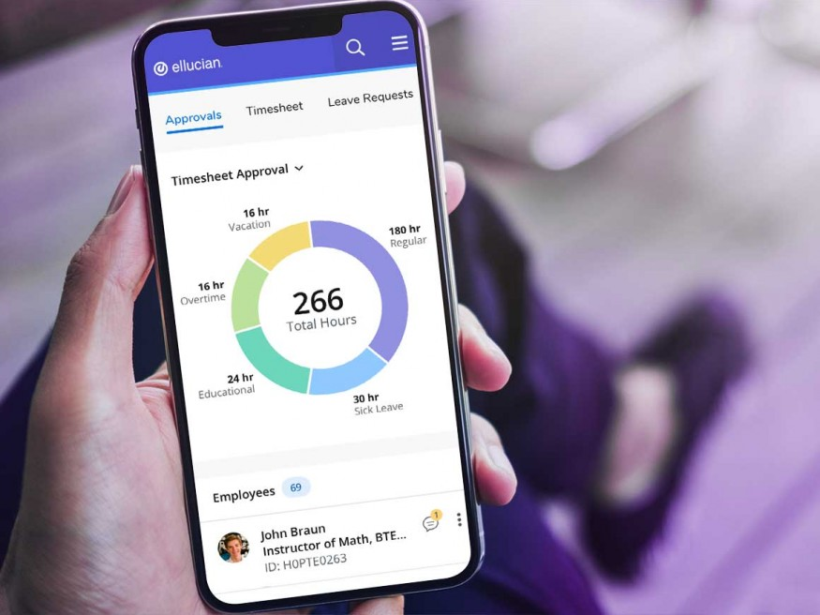Integrating Radio Frequency Identification (RFID) technology into Ellucian Banner, a prominent higher education ERP system, holds immense potential for campus efficiency. [8] By leveraging RFID-enabled student identification cards or devices, institutions can seamlessly enhance various operations. Through RFID integration, Ellucian Banner whose interface is shown in fig2.2 could automate attendance tracking, simplifying administrative tasks for instructors and offering real-time attendance data. RFID-equipped cards could also streamline library transactions, enabling quick borrowing and returning of materials without manual scanning. Additionally, RFID technology could bolster campus security by enabling access control systems that restrict entry based on authorized personnel.

Figure 2.2 Elucian Banner System using RFID

These enhancements can offer insights for strategic decision-making, resource allocation, and infrastructure planning. However, safeguarding data privacy and security remains paramount. Rigorous encryption and compliance with privacy regulations are imperative to ensure students' personal information is protected.

In conclusion, the fusion of RFID technology with Ellucian Banner opens avenues for efficiency, accuracy, and improved campus experiences. When executed with a strong commitment to data security, this integration can reshape administrative processes, enhance user satisfaction, and contribute to a more streamlined educational environment.

* Amano McGann:

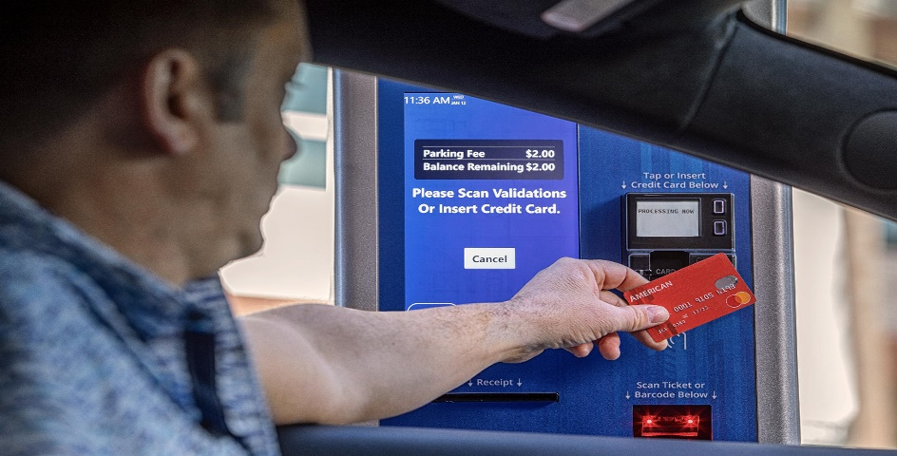

Figure 2.3 Amano McGann System for Parking and Access Control using RFID Technology

Amano McGann's integration of RFID technology into their parking and access control systems is a pivotal advancement. By incorporating Radio Frequency Identification (RFID), [3] seamless access becomes a reality through RFID-enabled cards or devices. As users' RFID devices interact with strategically placed readers, access is granted instantly, eliminating manual checks and enhancing convenience.

RFID ensures both accuracy and security. Encrypted signals prevent unauthorized duplication, bolstering protection against fraudulent access. The data collected from RFID transactions can be leveraged for analytics, optimizing space utilization and operational efficiency.

Furthermore, RFID technology's integration extends to comprehensive management through centralized software systems. This real-time insight enhances control over occupancy, billing, and user activity, leading to smoother operations and accurate billing. Data privacy remains paramount, necessitating strong encryption and adherence to regulations. In essence, Amano McGann's integration of RFID technology signifies a leap forward in user experience, operational efficiency, and data-driven decision-making.

* Infinite Campus: Infinite Campus integration with RFID technology presents a progressive approach to modernize school operations. By harmonizing the capabilities of Infinite Campus, a comprehensive student information system, with Radio Frequency Identification (RFID) technology, educational institutions can enhance various aspects of campus life. Through RFID-enabled cards or wearables, students' presence is seamlessly recorded, streamlining attendance tracking and minimizing disruptions to instructional time. [5] The real-time data synchronization between Infinite Campus and RFID readers ensures accurate attendance records and empowers educators to monitor student engagement more effectively. Furthermore, this integration extends beyond attendance to encompass access control, library management, and more, creating a unified ecosystem that simplifies administrative tasks and elevates the overall campus experience. However, meticulous attention to data security and privacy is imperative to ensure the successful implementation of this innovative solution.
* Trapeze Group: Trapeze Group's utilization of RFID technology signifies a transformative leap in transportation and fleet management. [1] By integrating Radio Frequency Identification (RFID) technology into their solutions, Trapeze Group optimizes operations and enhances passenger experiences. RFID-enabled cards or tags enable seamless electronic fare payment, reducing transaction times and congestion. Additionally, RFID-based vehicle tracking enhances fleet management precision, ensuring efficient routes, maintenance schedules, and real-time monitoring. Passengers benefit from streamlined boarding processes, while operators experience improved data accuracy for decision-making. However, ensuring data privacy and security is crucial to maintain public trust. Trapeze Group's integration of RFID technology exemplifies their commitment to innovation, efficiency, and customer-centric transport solutions.
* Identity: Identity verification (Identity) employing RFID technology is a groundbreaking solution enhancing security and efficiency. [5] By integrating Radio Frequency Identification (RFID) into identification cards or devices, individuals' information can be swiftly and accurately authenticated. When scanned by RFID readers, these devices transmit unique signals, confirming identities in real time. This technology is particularly valuable in secure access control, attendance management, and contactless verification processes, providing a streamlined and reliable way to ensure the authenticity of individuals and their access privileges.

**2.1.2 Research Gaps of Existing Literature**

1. Security and Privacy:

* Data Security: Vulnerabilities in RFID systems can expose sensitive personal information like student ids [2] and personal information. Research is needed on robust encryption methods, secure data storage, and access control mechanisms.
* Privacy Concerns: Balancing the convenience of RFID with individual privacy is crucial. Research can explore user-controlled data sharing, anonymous authentication, and opt-out mechanisms.

2. Integration and Interoperability:

* System Integration: Seamless integration with existing infrastructure like attendance management software, payment gateways, and access control systems is essential. Research on standardized protocols and open-source solutions can facilitate wider adoption.
* Interoperability: Compatibility with different [5] RFID tags and readers from various manufacturers would enhance flexibility and scalability. Research on universal standards and interoperable protocols can address this gap.

3. Usability and Accessibility:

* User Experience: Easy-to-use interfaces and intuitive interaction methods are crucial for widespread acceptance. Research on user-centered design, multilingual support, and accessibility features for differently-abled individuals is needed.
* Cost-Effectiveness: Balancing the benefits of RFID with implementation and maintenance costs is critical [6]. Research on cost-efficient solutions, energy-efficient tags, and extended reader lifespans can improve affordability.

4. Advanced functionalities:

* Context-aware applications: RFID systems [1] can go beyond basic access control and payments. Research on integrating location tracking, environmental sensors, or health monitoring capabilities can add new dimensions to these systems.
* AI-powered analytics: Leveraging artificial intelligence for data analysis can extract valuable insights from RFID data. Research on anomaly detection, fraud prevention, and predictive maintenance can enhance system effectiveness.

5. Ethical considerations:

* Social implications: The widespread use of RFID raises ethical concerns about dataveillance, social control, and potential discrimination. Research on ethical frameworks and responsible data governance practices is crucial.
* Environmental impact: The production and disposal of RFID tags can have environmental consequences. Research on sustainable materials, recycling programs, and energy-efficient systems can minimize the environmental footprint.

**2.1.3 Detailed Problem Analysis**

The existing systems for attendance tracking, payment processing, and access control in the college pose significant challenges that our project aims to address comprehensively.

**Attendance Tracking:**

* Manual Tracking Inefficiency: The current manual attendance methods are time-consuming and prone to errors, impacting the overall efficiency of the tracking process.
* Data Inaccuracy: Manual recording introduces unreliable attendance data, contributing to inaccuracies that hinder data integrity.
* Administrative Load: Faculty members invest valuable time in attendance tasks, affecting their overall productivity and efficiency.
* Real-time Data Absence: Manual systems lack real-time attendance information, impeding the ability to make prompt decisions based on current data.
* User Discomfort: Students experience inconvenience and dissatisfaction with manual attendance processes, affecting their overall experience.
* Privacy Concerns: Manual records raise privacy issues if mishandled or accessed improperly, posing potential risks.
* Integration Complexity: Integrating manual data with other systems proves challenging, hindering the seamless flow of information across various platforms.
* Limited Insights: Manual systems offer limited attendance trend insights, restricting the ability to analyze and address patterns effectively.
* Data Management Challenges: Storing and managing paper records is cumbersome, leading to organizational inefficiencies.
* Communication Hurdles: The lack of real-time data hampers effective communication, as stakeholders may not have access to the most up-to-date attendance information.

**Payment Processing:**

* Inconvenient Cash System: The current cash-based payment system is inconvenient and poses security risks, requiring a more secure and user-friendly alternative.
* Security Concerns: Carrying cash for purchases and handling large amounts on campus increases the risk of theft, necessitating a safer payment method.
* Tracking Challenges: Managing and tracking cash transactions present challenges, leading to potential accounting discrepancies that need addressing.

**Access Control:**

* Cumbersome Physical Methods: Access control managed through physical keys, swipe cards, or stationed security personnel is cumbersome and may not effectively prevent unauthorized access.
* Security Vulnerabilities: Lost or duplicated keys, shared or stolen swipe cards, and limited monitoring capabilities contribute to security vulnerabilities.
* Resource Intensive: Restricted areas pose additional challenges in managing access and may require additional resources for effective monitoring.

In summary, our project aims to tackle these issues comprehensively by introducing efficient, automated, and secure systems for attendance tracking, payment processing, and access control, enhancing the overall functionality and security of the college environment.

**2.1.4 Survey of Tools and Technologies Used**

1. RFID Technology:

* RFID Tags: These are small electronic devices that store unique identifiers and communicate with RFID readers using radio waves.
* RFID Readers: Devices that emit radio waves to communicate with RFID tags and capture their unique identifiers.
* RFID Antennas: Antennas are used to enhance the communication range between RFID readers and tags.
* RFID Middleware: Software that manages data flow between RFID hardware and the central database.

1. Microcontrollers and Hardware:

* Arduino: An open-source electronics platform commonly used for prototyping and building hardware systems.
* Raspberry Pi: A small computer that can serve as a central hub for data processing and communication.
* Breakout Boards: Circuit boards that provide easy access to microcontroller pins and functionalities.

1. Database Management:

* MySQL: A widely used open-source relational database management system (RDBMS).
* PostgreSQL: Another powerful open-source RDBMS known for its advanced features.
* MongoDB: A NoSQL database that can be useful for handling large volumes of data.

1. Web Development:

* HTML, CSS, JavaScript: Essential web technologies for building user interfaces.
* Frontend Frameworks: Tools like React, Angular, or Vue.js for creating dynamic and responsive web interfaces.
* Backend Frameworks: Options like Node.js, Django, or Ruby on Rails for building server-side logic.

1. Data Security and Encryption:

* AES Encryption: Advanced Encryption Standard for securing data transmission and storage.
* SSL/TLS: Secure Socket Layer/Transport Layer Security protocols for secure communication over networks.

1. User Authentication and Access Control:

* OAuth: A protocol for authorization, enabling secure access to resources.
* JWT: JSON Web Tokens for creating and verifying access tokens.

1. Cloud Services:

* Amazon Web Services (AWS), Microsoft Azure, Google Cloud: Cloud platforms offering scalable computing resources and storage.

1. Mobile App Development:

* Android Studio: Development environment for creating Android mobile applications.
* Swift, Xcode: Tools for developing iOS applications.

1. Networking:

* Wi-Fi: Wireless technology for connecting RFID readers and other devices.
* Ethernet: Wired connectivity for reliable and stable data transmission.

1. Data Analysis and Visualization:

* Python: A versatile programming language with libraries like Pandas and Matplotlib for data analysis and visualization.
* Power BI, Tableau: Tools for creating interactive and informative data visualizations.

1. Project Management:

* Git: A distributed version control system for tracking changes in code and collaborating with a team.
* IRA, Trello, Asana: Project management tools for planning, tracking, and organizing tasks.

**2.1.5 Summary**

In contrast to existing solutions like Blackboard Attendance, Ellucian Banner, Amano McGann, Infinite Campus, Trapeze Group, and Identitv, our RFID-based card system aims to provide a comprehensive and tailored approach to campus services, specifically designed for our institution.

Our project focuses on seamlessly integrating RFID technology to redefine campus services, offering a multifaceted solution for attendance tracking, payment processing, and access control. Unlike some existing solutions that may address specific aspects, our system aims to holistically streamline these processes, providing an all-encompassing solution for students, faculty, and staff.

One key differentiator is the emphasis on real-time automation and accuracy in attendance tracking. Our RFID-enabled smart cards facilitate swift entry into various campus facilities, automatically recording attendance and minimizing the need for manual tracking. This not only enhances efficiency but also ensures precise and up-to-date attendance records, providing valuable insights into student engagement.

Furthermore, our system extends beyond attendance to offer secure, contactless payment options at on-campus vendors, eliminating the reliance on cash transactions. The integration of encryption and authentication protocols prioritizes security, mitigating risks associated with unauthorized access.

In terms of access control, our RFID-based cards provide a more effective and secure means of restricting entry to different campus areas. The system is designed to enhance overall security by preventing unauthorized access to dormitories, labs, and other restricted zones.

Additionally, our project addresses the potential concern of data security by incorporating robust encryption measures and ensuring compliance with privacy regulations. We are committed to safeguarding student information and privacy, providing a secure and reliable system for campus services.

In summary, our RFID-based card system distinguishes itself by offering a holistic and tailored solution that addresses the specific needs of our institution, providing a seamless and secure experience for students, faculty, and staff in attendance tracking, payment processing, and access control.

**2.2 Software Requirement Specification**

**2.2.1.1 Purpose**

The purpose of this Software Requirements Specification (SRS) is to precisely define and outline the functional and non-functional requirements for the development of an RFID-based attendance tracking system. This document serves as a comprehensive guide for the development team, stakeholders, and all involved parties, ensuring a clear understanding of the system's features, functionalities, and performance expectations. By detailing the specific software requirements, the SRS aims to facilitate efficient development, testing, and validation processes, ultimately leading to the successful implementation of a secure, accurate, and user-friendly attendance tracking solution within the educational institution.

**2.2.1.2 Intended Audience and Reading Suggestions**

Intended Audience: The "Intended Audience" section of the Software Requirements Specification (SRS) identifies the individuals and groups who will be reading and utilizing the document throughout the project’s lifecycle.

1. Development Team: Software engineers, programmers, and developers who will be responsible for designing, coding, and testing the system.
2. Project Managers: Those overseeing the project's progress, coordinating tasks, and ensuring timely delivery.
3. Quality Assurance Team: Individuals responsible for testing the system against the defined requirements to ensure its functionality and reliability.
4. Designers: UI/UX designers responsible for creating the user interface and overall user experience of the system.
5. System Architects: Professionals who will design the system’s overall structure and ensure its scalability and integration.
6. Stakeholders: Including representatives from the educational institution, such as administrators, faculty, and IT personnel, who have an interest in the project's success.
7. Clients: If the system is being developed for an external client, they would need to review the SRS to ensure their requirements are accurately captured.

Reading Suggestions: For those reading the SRS, it's essential to have a clear understanding of the project's objectives, scope, and requirements. Suggested reading approaches include:

1. Review of Complete Document: Readers should start by going through the entire SRS to get a holistic view of the project, including its purpose, scope, and requirements.
2. Functional Requirements Section: Developers and programmers should focus on the functional requirements section to understand the system's expected behavior and features.
3. Non-Functional Requirements Section: Those involved in system performance and security should carefully review the nonfunctional requirements to ensure compliance with standards.
4. Integration and Interfaces Section: System architects and integration specialists should pay attention to how the system interfaces with other systems and databases.
5. System Constraints and Assumptions: Understanding the constraints and assumptions helps stakeholders recognize the limitations and expectations of the system.
6. Use Cases and Scenarios: Reading specific use cases and scenarios helps stakeholders envision how the system will function in different real-world situations.
7. References: Readers should refer to any cited standards, regulations, or guidelines to ensure compliance with industry best practices.

By tailoring their reading approach based on their roles and responsibilities, the intended audience can effectively utilize the SRS to contribute to the successful development and implementation of the RFID based attendance tracking system.

**2.2.1.3 Project Scope**

The scope of this project encompasses the comprehensive development, thorough testing, and seamless integration of software components. These components are designed to facilitate key functionalities of the RFID card system, including attendance tracking, secure payment processing, and efficient access control. By establishing a digital framework that harmonizes RFID card readers, central databases, and existing campus systems, this software solution aims to elevate user experience, strengthen security measures, and streamline administrative tasks.

**2.2.2 Overall Description**

The RFID card system software functions as a critical intermediary within the campus environment, seamlessly linking RFID card readers to the central database. Its capabilities encompass real-time attendance tracking, cashless payment processing, access control, integration with existing systems, and a user-friendly interface for intuitive navigation.

By facilitating the accurate flow of data, the software empowers the entirety of the RFID card system, thereby fostering a culture of accountability, enabling secure transactions, managing controlled access, and optimizing overall campus operations. This software acts as a linchpin, ensuring smooth coordination between various components and contributing to the efficient functioning of a technologically advanced and secure campus ecosystem.

**2.2.2.1 Product Perspective**

In the broader context of the campus environment, the RFID card system software acts as a vital intermediary. It bridges the gap between RFID card readers stationed across various campus locations and the central database. Through this interface, the software ensures seamless communication, allowing data to flow accurately and efficiently. Additionally, the software integrates seamlessly with existing student information systems, financial systems, and security systems. By maintaining a cohesive exchange of information, the software empowers the entire RFID card system, ensuring that accurate attendance records, secure payments, and controlled access are effectively managed.

**2.2.2.2 Product Features**

The RFID card system software boasts an array of advanced features designed to optimize campus operations. These include:

1. Attendance Tracking: Through real-time RFID card swipes, the system automatically updates a centralized database, offering users immediate access to their attendance records. This fosters accountability and empowers students and staff to monitor their engagement.
2. Payment Processing: Harnessing RFID technology, the software enables seamless cashless payments across campus facilities. The RFID cards facilitate secure transactions, while the system provides a transparent view of payment history, promoting responsible financial management.
3. Access Control: The software ensures secure entry to restricted areas by authorizing RFID card holders. Administrators can manage access permissions and review security logs, bolstering overall campus safety.
4. Integration: By seamlessly interfacing with existing student information, financial, and security systems, the software minimizes data redundancy and enhances accuracy. This integration optimizes data exchange and reduces the administrative burden.
5. User-Friendly Interface: Tailored for both web and mobile platforms, the interface is user-centric, emphasizing intuitive navigation. This dashboard provides easy access to attendance records, payment histories, and access control settings, promoting a seamless user experience.

**2.2.3 External Interface Requirements**

**2.2.3.1 User Interfaces**

The user interface (UI) within the RFID card system software stands as a pivotal conduit through which users engage with and manage the system's functionalities. It operates as a visual and interactive bridge, fostering seamless communication between users and underlying software processes.

Crafted with meticulous consideration, the UI ensures a consistent user experience across various devices, encompassing both web and mobile platforms. This adaptability empowers users to effortlessly access RFID card system capabilities through their preferred devices, be it laptops, desktops, smartphones, or tablets.

Central to the UI's architecture is a user-centric dashboard that serves as an intuitive hub for navigating the system's core features. Streamlined to encompass attendance tracking, payment processing, and access control settings, this dashboard amalgamates critical functions into a cohesive and accessible space, enabling users to efficiently manage their campus interactions. Designed with a deliberate focus on user efficiency, the dashboard seamlessly transitions between functionalities, eliminating the need for navigating through multiple screens. This approach optimizes user workflow and contributes to an enhanced overall experience.

The UI's responsive design, adapting seamlessly varied screen sizes and orientations on different devices, ensures consistent organization and legibility. This quality guarantees a user-friendly experience, be it on large desktop displays or compact smartphone screens. In essence, the RFID card system's UI encapsulates accessibility, intuitiveness, and responsiveness, epitomized by its central dashboard housing key functions and its adaptability to diverse devices. This synergy enhances user engagement, boosts efficiency, and crucially contributes to the triumphant execution and user acceptance of the RFID card system endeavour.

**2.2.3.2 Hardware Interfaces**

In the RFID card system context, hardware interfaces hold a vital role in establishing real-time connections between software and strategically placed RFID card readers across the campus. These readers are positioned in key locations like classrooms, libraries, and entry points, ensuring comprehensive coverage.

When a user swipes their RFID card, the reader translates this action into an electronic signal containing encoded user information. This signal is sent through the hardware interface to the software. The software rapidly interprets the signal and executes context-specific actions. For instance, in attendance tracking, the software updates the database; for payment processing, it verifies transactions and logs them; and in access control, entry permissions are granted or denied. This bidirectional communication ensures real-time accuracy, enhancing the system's functionality and reliability by automating previously manual processes. This seamless interaction between RFID card readers and software bolsters the effectiveness of the RFID card system.

**2.2.3.3 Software Interfaces**

The RFID card system app, an integral facet of the broader system, offers users a user-centric platform replete with functionalities. Its user-friendly interface facilitates easy access to attendance records, secure campus payments, and access control. By amalgamating these aspects, the app elevates efficiency, transparency, and user satisfaction.

* Interfacing with Student Information Systems (SIS) furnishes critical user data, including profiles and schedules, for attendance tracking and authentication. This seamless integration ensures real-time attendance insight while simplifying access to services.
* Integration with financial systems streamlines payment processing, ensuring accuracy and security. Transactions are seamlessly recorded, fostering transparency and accountability.
* Interfacing with security systems strengthens access control and event logging. Authorized personnel manage permissions, enhancing security, while a comprehensive log offers insights into user movements, streamlining secure area management. In sum, the app's integrated functionalities optimize user experience, efficiency, and security within the RFID card system.

**2.2.4 Other Non-functional Requirements**

* The system shall be reliable and available at all times during campus operating hours.
* The system shall have a response time of no more than 5 seconds from the time a user presents their RFID card to the reader until their attendance is recorded.
* The system shall be scalable to accommodate increasing numbers of students, faculty, and staff.
* The system shall be secure and protect user privacy by only collecting necessary data and storing it securely.
* The system shall be user-friendly, with clear instructions on how to use the RFID cards and readers, and easily accessible reports for students, faculty, and staff.

**2.2.4.1 Performance Requirements**

* The system shall have low latency, providing real-time attendance tracking capabilities to ensure accurate and timely data.
* The system shall be able to handle peak loads during busy periods, such as the start of classes or events.
* Response times for card reads and database transactions shall be within acceptable limits to provide a seamless user experience.
* The system shall have high availability, with minimal downtime to ensure continuous access to services.

**2.2.4.2 Safety Requirements**

* The system shall not pose any health hazards to users, including electromagnetic radiation levels within acceptable safety limits.
* RFID readers and associated equipment shall be installed securely to prevent physical harm or accidents.
* Secure transactions shall be facilitated, ensuring that cashless payments and sensitive data remain protected.

**2.2.4.3 Security Requirements**

* Access to the centralized database shall be restricted to authorized personnel only, using secure authentication methods.
* User data, including personal information and attendance records, shall be encrypted to protect against unauthorized access or data breaches.
* The system shall log and monitor all access and modification attempts to detect and prevent security breaches. The cards shall be encrypted or secured to prevent cloning or tampering.
* In case of a lost or stolen RFID card, there shall be a secure process to disable the card to prevent unauthorized access.

**2.3 Cost Analysis**

Table 3: Represents the detailed cost analysis of RFID system.

|  |  |  |  |
| --- | --- | --- | --- |
| **Sr. No.** | **Components Required for Hardware** | **Individual Cost X No. of Components Required** | **Total Amount of Components** |
| 1. | Microcontroller | Rs. 800 X 3 | Rs. 2400 |
| 2. | Breakout Boards | Rs. 2500 X 3 | Rs. 7500 |
| 3. | RFID Tags | Rs. 20 X 10 | Rs. 200 |
| 4. | RFID Reader | Rs. 300 X 3 | Rs. 900 |
| 5. | Display | Rs. 500 X 3 | Rs. 1500 |
| 6. | Wired and other electronic components | Rs. 500 | Rs. 500 |
| 7. | Miscellaneous | Rs. 1000 | Rs. 1000 |

Total amount of the components required for the hardware = Rs. 14,000/-

Let's provide a more detailed explanation of the hardware components required for the project:

1. Microcontroller: A microcontroller is a small integrated circuit that acts as the brain of the system. It contains a CPU (Central Processing Unit), memory, and various I/O (Input/Output) ports to interact with other hardware components. In this project, three microcontrollers are required, likely to be used in different locations or sections of the campus. They will handle tasks such as reading data from RFID readers, processing information, and communicating with the centralized database.
2. Breakout Board: A breakout board is a circuit board that provides 9easy access to the pins and functionalities of a microcontroller. It simplifies the process of connecting various sensors, modules, and peripherals to the microcontroller. In this project, three breakout boards are needed, probably one for each microcontroller, to facilitate easy integration and expansion of the system.
3. RFID Tags: RFID tags are small electronic devices that contain a unique identifier and can be attached to objects, such as student ID cards, faculty/staff badges, or other items relevant to the attendance tracking system. When an RFID tag comes within range of an RFID reader, it transmits its unique identifier, allowing the system to identify and track individuals.
4. RFID Reader: RFID readers are devices that use radio frequency signals to communicate with RFID tags. They can detect and read the unique identifiers stored in the RFID tags. In this project, three RFID readers are required, probably placed in different key locations like classrooms, shops, or entry points, to record the presence of individuals with RFID tags.
5. Display: Displays are output devices that provide visual feedback to users. In this project, three displays are needed, likely connected to the microcontrollers, to show information such as successful card read notifications or other relevant data to users.
6. Wires and Other Electronic Components: This category includes various cables, connectors, resistors, capacitors, and other electronic components needed to assemble and interconnect the hardware components effectively. These components play a vital role in ensuring proper electrical connections and signal transmission within the system.
7. Miscellaneous: The miscellaneous category may include items like power supplies, enclosures, mounting brackets, and any other components or materials required to set up and protect the hardware components of the system.

**2.4 Risk Analysis**

Performing a risk analysis is essential for any project to identify potential challenges and mitigate them effectively. Here's the Table 4 depicting the risk analysis for the RFID card system project:

Table 4: explains the extensive risk analysis explaining the risk and mitigation.

|  |  |  |  |
| --- | --- | --- | --- |
| **Sr. No.** |  | **Risk** | **Mitigation** |
| 1. | Data Security and Privacy Concerns | The system involves storing personal data of students, faculty, and staff in a centralized database. If proper security measures are not implemented, there is a risk of unauthorized access or data breaches, leading to privacy violations and identity theft. | Employ strong encryption methods, access controls, and regular security audits to safeguard the data. Follow data protection regulations and best practices to ensure compliance and user trust. |
| 2. | Hardware and Software Compatibility | Different hardware components, software libraries, and microcontroller boards may have compatibility issues, causing system malfunctions or integration challenges. | Conduct thorough testing and validation of hardware and software components before deployment. Ensure that the selected components are well-documented and have a track record of successful integration. |
| 3. | Technical Malfunctions and Downtime | The RFID readers, microcontrollers, or database server may experience technical failures, resulting in attendance tracking disruptions and system downtime. | Implement redundancy and failover mechanisms for critical components. Establish a maintenance and backup plan to minimize downtime and quickly restore functionality in case of failures. |
| 4. | Reliability of RFID Detection | RFID technology can sometimes suffer from interference or signal loss, leading to inaccurate attendance records | Test the RFID system under various scenarios and environments to identify and address potential issues. Employ multiple RFID readers in key locations to enhance reliability. |
| 5. | User Acceptance and Resistance | Students, faculty, or staff may resist adopting the new RFID system, leading to poor user acceptance and low utilization rates. | Conduct thorough use training and provide clear communication about the benefits and ease of using the system. Address any concerns or misconceptions and ensure that the system adds value to the campus community. |
| 6. | Integration Challenges with Existing Systems | Integrating the new RFID system with existing campus systems, such as student information systems or payment gateways, might encounter compatibility challenges. | Collaborate closely with IT and administrative departments to plan and execute the integration. Create well-defined APIs or middleware to facilitate smooth data exchange between systems. |
| 7. | Cost Over-runs | The project might exceed the initial cost estimation due to unforeseen expenses or scope changes | Conduct regular cost monitoring and maintain a buffer in the budget for unexpected expenses. Regularly review the project's progress and expenses to ensure alignment with the budget. |
| 8. | Lack of Scalability | If the system is not designed to handle future growth and increased user demands, it might become inefficient or limited in its capacity. | Plan for scalability from the outset, allowing the system to handle a growing number of users and locations. Consider future expansion needs and design the system accordingly |

**METHODOLOGY ADOPTED**

**3.1 Investigative Techniques**

1. Survey: The survey was conducted to gather requirements from stakeholders, such as students, faculty, and staff. The survey asked questions about the current methods of attendance tracking, payment processing, and access control on campus. The survey also asked about the features that users would like to see in a new system. The survey was distributed to a sample of students, faculty, and staff, and a total of 100 responses were collected.
2. Literature Review: The literature review was conducted to research the use of RFID technology in campus management. The literature review identified several best practices for using RFID technology in campus management, such as:

* Using RFID readers at key locations on campus, such as entrances to buildings, in classrooms, and at vending machines.
* Integrating the RFID system with existing systems on campus, such as the student information system or the library system.
* Using security features in the RFID system to protect the privacy of users.

1. Prototyping: The prototype of the system was created to test the functionality and usability of the system. The prototype was created using a web-based development framework. The prototype allowed users to swipe their RFID cards to record attendance, make cashless payments, and gain access to restricted areas. The prototype was tested by a group of students, faculty, and staff, and the feedback from the testers was used to improve the design of the system.

**3.2 Proposed Solution**

The proposed solution for the RFID card system for campus management is a web-based system that uses RFID readers to track the movement of people on campus. The system would allow users to swipe their RFID cards to record attendance, make cashless payments, and gain access to restricted areas. The system would update data in real-time, provide attendance records and payment history, and allow administrators to manage access control permissions. The system would be implemented in the following phases:

**Phase 1:** Requirements gathering: The project team would gather requirements from stakeholders, such as students, faculty, and staff. This would help to define the scope of the project and identify the specific features that the system should have.

**Phase 2:** System design: The project team would design the system architecture and create the user interface. This would involve selecting the appropriate RFID technology, designing the database, and creating the software applications.

**Phase 3:** Implementation: The project team would implement the system by installing the RFID readers, deploying the software applications, and training the users.

**Phase 4:** Testing: The project team would test the system to ensure that it meets the requirements and is free of errors.

**Phase 5:** Deployment: The project team would deploy the system to production and make it available to users.

**3.3 Work Breakdown Structure**

The project can be divided into 10 different modules and then will be interfaced as per dataflow of the project. The Gantt chart in Fig 3 given below defines the duration of each module or activity that sums up to the overall completion of the project.

**Module 1:** Ideation

**Module 2:** Literature Survey and defining Specifications

**Module 3:** Hardware Assembly

**Module 4:** Documentation

**Module 5:** Application Designing and Optimization

**Module 6:** Backend Development

**Module 7:** Application Development 41

**Module 8:** Testing

**Module 9:** Integration and modification

**Module 10:** Integration and Final Report.

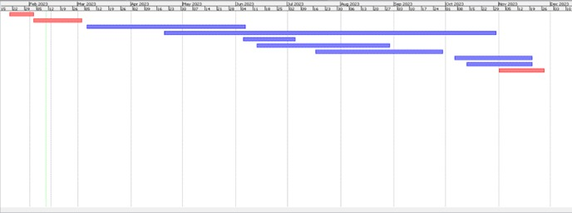

Figure 3: Gantt Chart explaining the complete work breakdown structure.

**3.4 Tools and Technologies Used**

The system would be developed using the following technologies:

* RFID readers: The RFID readers will be used to scan the RFID cards and identify the users.
* Software applications: The software applications will be used to track the movement of users on campus, record attendance, make cashless payments, and manage access control permissions.
* Database: The database will store the data about the users, such as their RFID card information, attendance records, and payment history.
* Web server: The web server will be used to host the software applications and make them available to users.
* Cloud computing: The cloud computing platform will be used to store the data and run the software applications.

**DESIGN SPECIFICATION**

Table 5:describes the diagrams used for design of RFID system

|  |  |  |
| --- | --- | --- |
| **Sr. no.** | **Diagram Name** | **Description** |
| 1. | Block Diagram | Block diagrams show a high-level view of the product under development and their interaction with different components including the sensors, actuators and servers. |
| 2. | Sequence Diagram | A sequence diagram simply depicts interaction between objects in a sequential order i.e., the order in which these interactions take place. We can also use the terms event diagrams or event scenarios to refer to a sequence diagram. |
| 3. | Use-case Diagram | A use case diagram at its simplest is a representation of a user’s interaction with the system that shows the relationship between the user and the different use cases in which the user is involved. |
| 4. | Activity Diagram | Activity diagrams are graphical representations of workflows of stepwise activities and actions with support for choice, iteration and concurrency. |
| 5. | Data Flow Diagram | A data-flow diagram (DFD) is a way of representing a flow of a data of a process or a system (usually an information system). |
| 6. | Entity-Relationship Diagram | Entity Relationship (ER) model is a high-level conceptual data model diagram. ER modelling helps you to analyse data requirements systematically to produce a well-designed database. The Entity-Relation model represents real-world entities and the relationship between them. It is considered a best practice to complete ER modelling before implementing your database. |
| 7. | Collaboration Diagram | Collaboration diagrams (known as Communication Diagram in UML 2.x) are used to show how objects interact to perform the behaviour of a particular use case, or a part of a use case. Along with sequence diagrams, collaboration is used by designers to define and clarify the roles of the objects that perform a particular flow of events of a use case. They are the primary source of information used to determining class responsibilities and interfaces |
| 8. | Gantt Chart Diagram | A Gantt chart is a type of bar chart that illustrates a project schedule, named after its inventor, Henry Gantt, who designed such a chart around the years 1910–1915. Modern Gantt charts also show the dependency relationships between activities and current schedule status. |
| 9. | Class Diagram | Class diagram describes the attributes and operations of a class and also the constraints imposed on the system. The class diagrams are widely used in the modelling of objectoriented systems because they are the only UML diagrams, which can be mapped directly with object-oriented languages. |
| 10. | State Diagram | State Diagram is a diagram that depicts the different states the project has and their transitions on receiving particular inputs. It is a model that depicts the functionality of the system. |
| 11. | Component Diagram | Component Diagram is a pictorial representation of various components that the product has and it also highlights the various dependencies between the components. |
| 12. | Interface Diagram | Interface Diagram is an important design document diagram that highlights how the various components function through the interfaces that are designed at a higher level and also how various actors can use the interfaces to perform certain functionality through the system. |

**4.1 System Architecture**

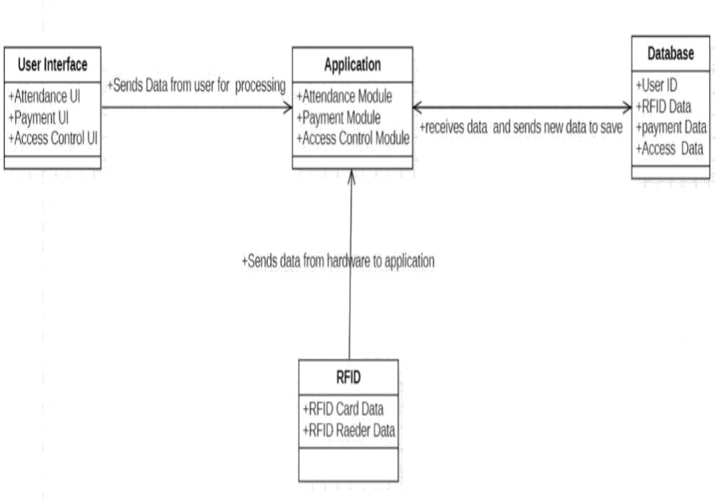

Figure 4.1: System Architecture

**4.2 Design Level Diagrams**

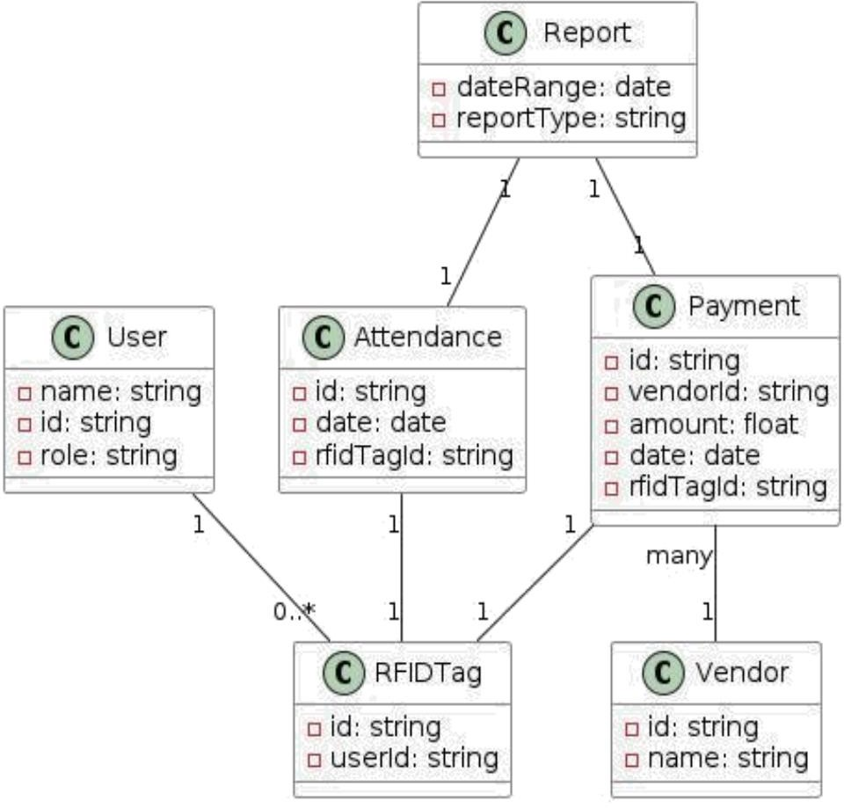

Figure 4.2: Design level diagram

**4.3 User Interface Diagrams**

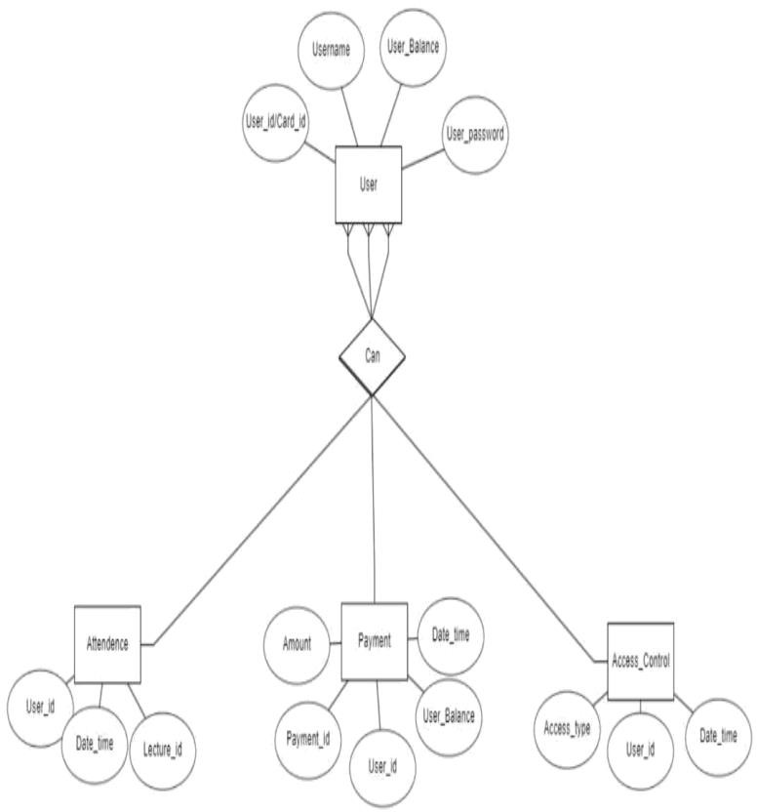

Figure 4.3: ER diagram

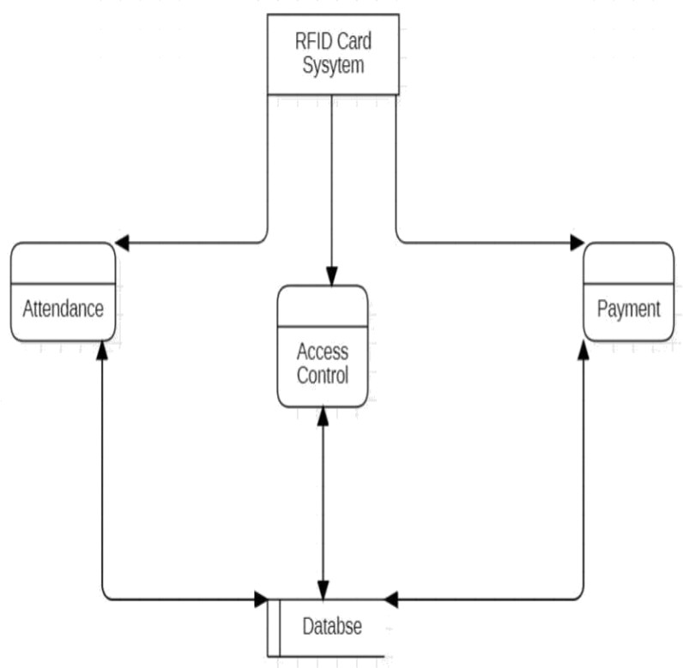

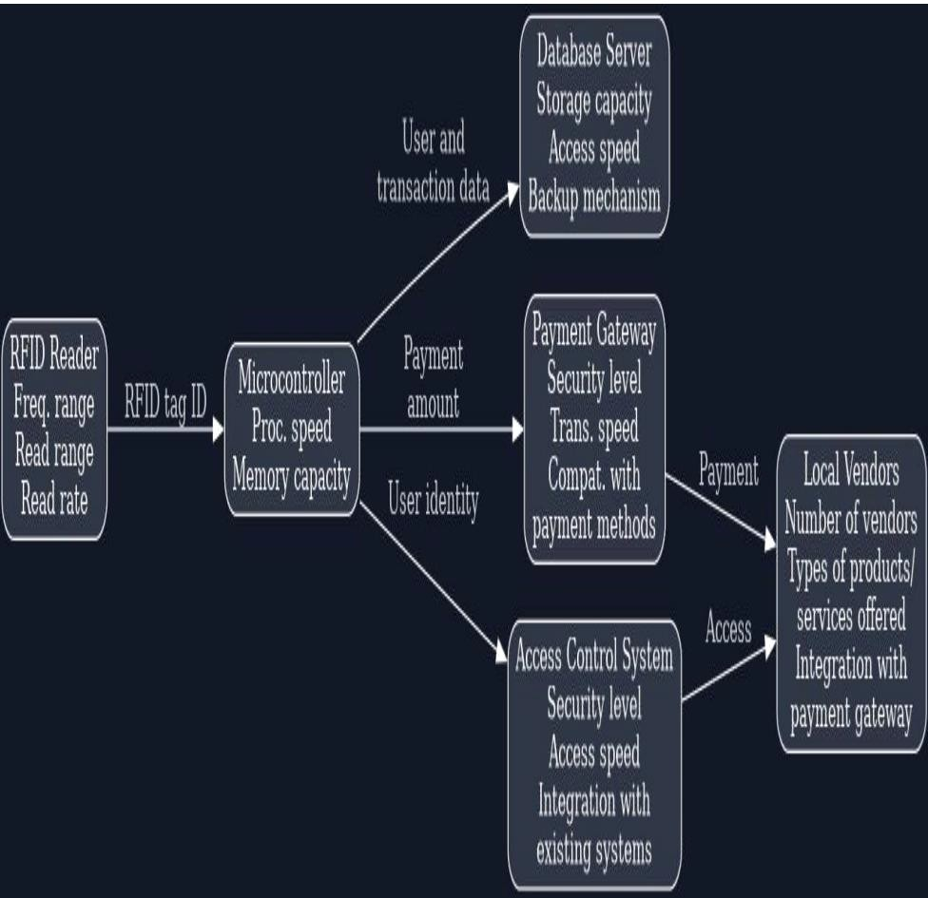

Figure4.4: Block Diagram

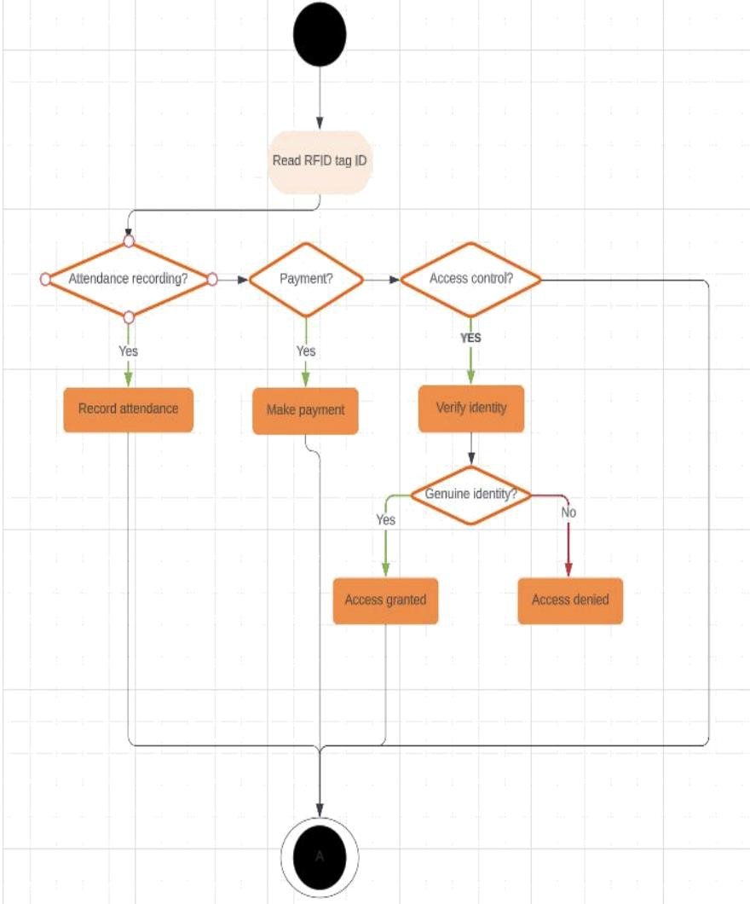

Figure 4.5: Activity diagram

**IMPLEMENTATION AND EXPERIMENTAL RESULTS**

**5.1 Experimental Setup**

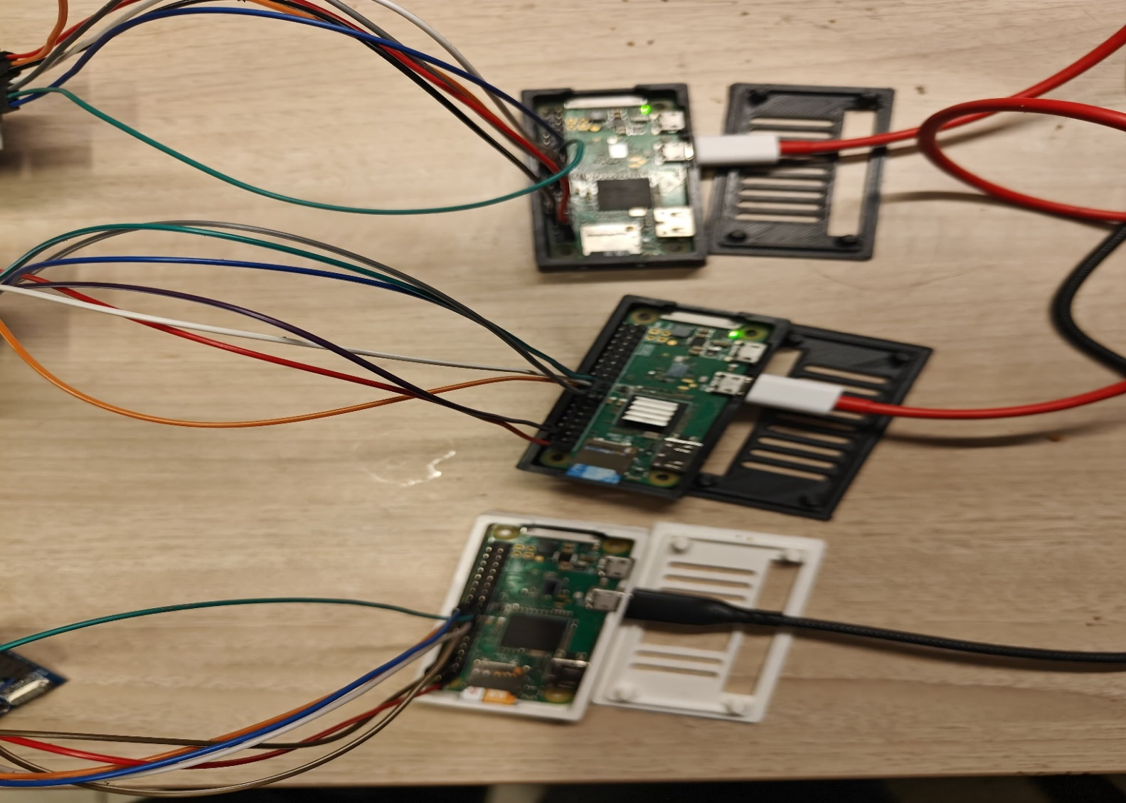

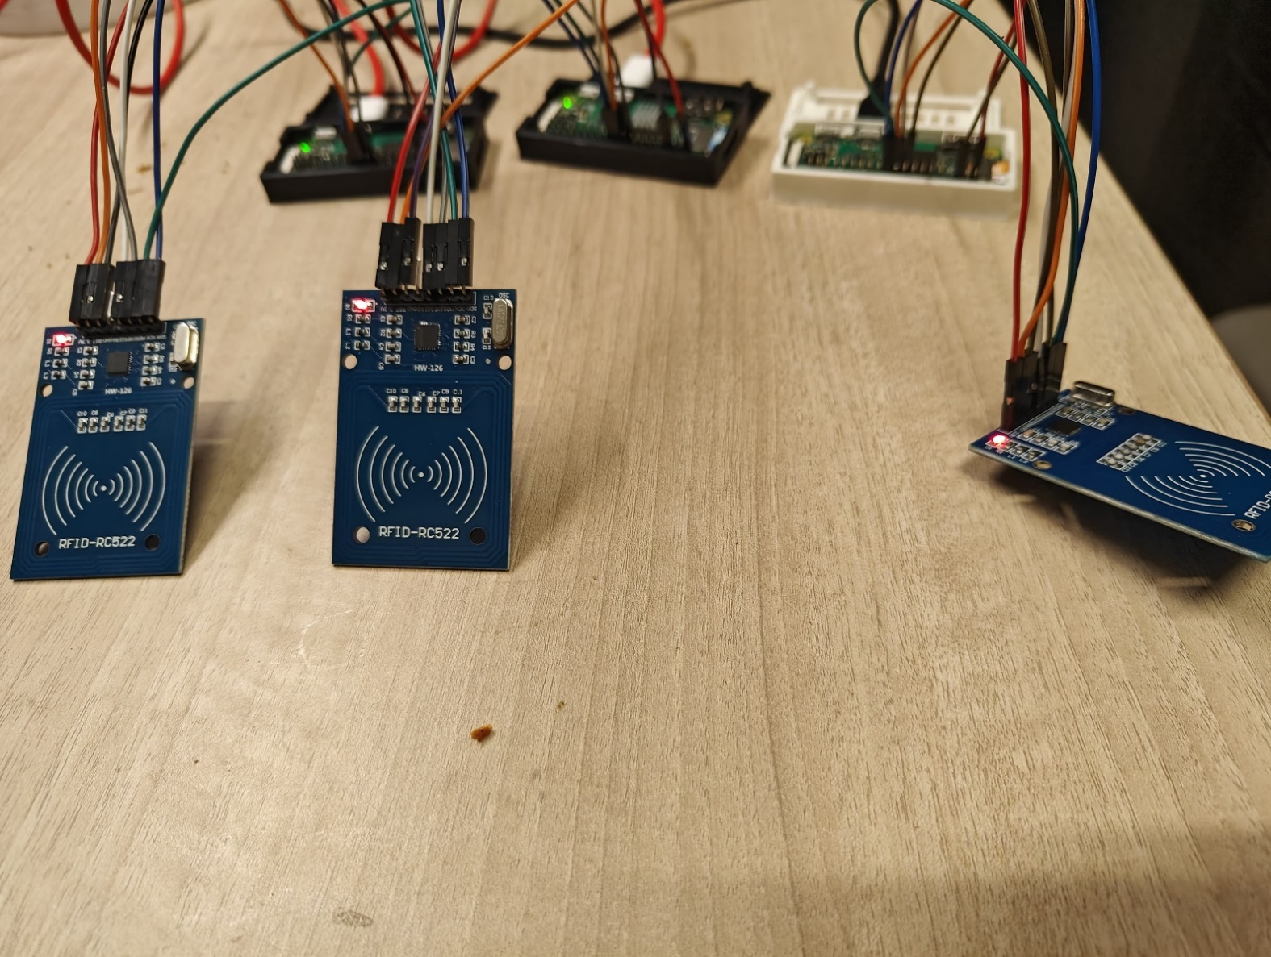Figure 5.1: Experimental setup showing the setup of Attendance Tracking, Payments, Access Control circuits.

**5.2 Experiment Analysis**

**5.2.1 Data**

1. Data Sources: The success of our RFID-based campus services system relies significantly on the quality and appropriateness of the data utilized in its development. Primary data sources include information related to student attendance, payment transactions, and access control events. The data is sourced from campus records, attendance sheets, and existing payment systems, ensuring a representative and comprehensive dataset.
2. Data Cleaning and Feature Extraction: The collected data undergoes a meticulous data cleaning process to rectify any inconsistencies, errors, or missing entries. This step is important for accurately performing the attendance of the users. The desired features were extracted and those attributes were used as the data for cross verification and validation of users.

**5.2.2 Performance Parameters**

1. System Responsiveness: Assess the overall responsiveness of the system. Measure the time it takes for the system to respond to user inputs, such as card swiping, payment initiation, and access requests.
2. Scalability: Evaluate the system's ability to handle an increasing number of users and transactions. Measure how well the system scales with growing demands.
3. Security Effectiveness: Assess the effectiveness of security measures in protecting sensitive data and ensuring secure access control. Verify the robustness of encryption and authentication protocols.
4. User Experience: Gather feedback on the user experience through surveys or usability testing. Measure user satisfaction and identify areas for improvement in the user interface and overall interaction.
5. Resource Utilization: Monitor the utilization of hardware resources such as CPU, memory, and network bandwidth. Optimize resource usage for efficient system performance.
6. Error Handling and Reliability: Evaluate the system's ability to handle errors gracefully and recover from failures. Measure the overall reliability of the system in various scenarios.

**5.3 Working of the Project**

**5.3.1 Procedural Workflow**

**Attendance Tracking System**

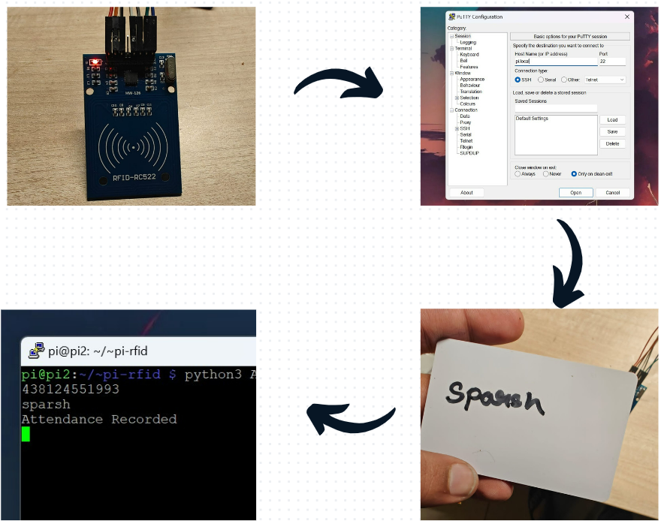

Figure 5.2: Figure Procedural Workflow of Attendance Tracking System

**Access Control System**

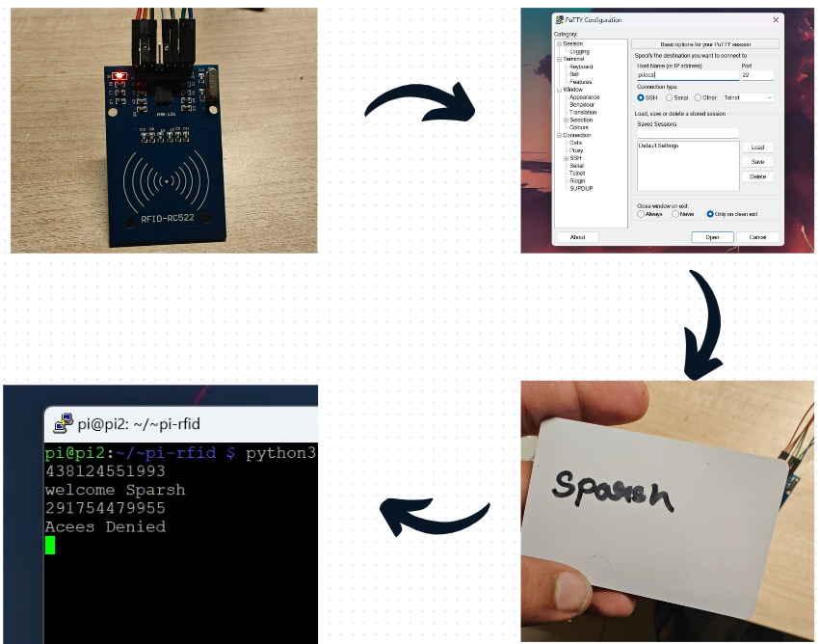

Figure 5.3:Figure Procedural Workflow of Access Control System

**5.3.2 Algorithmic Approaches Used**

**User registration**

Pseudocode:

Initialize GPIO, LCD, RFID reader, and database connection

try:

while True:

DisplayMessageOnLCD('Place Card to register')

# Read RFID card

id, text = ReadRFIDCard()

# Query database for user with the given RFID ID

cursor.execute("SELECT id FROM users WHERE rfid_uid = " + str(id))

existing_user = cursor.fetchone()

# Check if user exists

if RowCount(existing_user) >= 1:

DisplayMessage("Overwrite existing user?")

overwrite = GetUserInput("Overwrite (Y/N)? ")

if overwrite[0] == 'Y' or overwrite[0] == 'y':

DisplayMessage("Overwriting user.")

Sleep(1)

sql_update = "UPDATE users SET name = %s WHERE rfid_uid = %s"

else:

ContinueToNextIteration()

else:

sql_insert = "INSERT INTO users (name, rfid_uid) VALUES (%s, %s)"

DisplayMessage("Enter new name")

new_name = GetUserInput("Name: ")

DisplayMessage("Enter room no")

room_no = GetUserInput("Room no: ")

# Execute SQL query to insert or update user information

if sql_update is not None:

cursor.execute(sql_update, (new_name, id))

else:

cursor.execute(sql_insert, (new_name, id))

CommitChangesToDatabase()

Sleep(2)

finally:

CleanupGPIO()

**Attendance Tracking System**

Pseudocode:

Initialize GPIO, RFID reader, and database connection

try:

while True:

DisplayMessage("Place Card to record attendance")

# Read RFID card

id, text = ReadRFIDCard()

# Query database for user with the given RFID ID

result = ExecuteSQLQuery("SELECT id, name FROM users WHERE rfid_uid = " + str(id))

# Check if user exists

if RowCount(result) >= 1:

DisplayMessage("Welcome " + result[1])

# Record attendance in the database

ExecuteSQLQuery("INSERT INTO attendance (user_id) VALUES (%s)", (result[0],))

CommitChangesToDatabase()

else:

DisplayMessage("User does not exist.")

Sleep(2)

finally:

CleanupGPIO()

**Payment Processing**

# Table structure for iitjstud

CREATE_TABLE iitjstud:

id INT(11) NOT NULL,

username TEXT,

name TEXT,

pass TEXT,

tag TEXT,

tag_no TEXT,

amount INT(11) DEFAULT NULL,

date TEXT,

email VARCHAR(45) DEFAULT NULL,

PRIMARY_KEY(id)

# Table structure for seller

CREATE_TABLE seller:

service_id INT(11) NOT NULL,

amount INT(11) DEFAULT NULL,

pass TEXT,

username TEXT,

name VARCHAR(45) DEFAULT NULL,

email VARCHAR(45) DEFAULT NULL,

PRIMARY_KEY(service_id)

# Table structure for transactions

CREATE_TABLE transactions:

id INT(11) NOT NULL,

from TEXT,

from_id_tag TEXT,

to_id INT(11) DEFAULT NULL,

to TEXT,

amount INT(11) DEFAULT NULL,

time TEXT,

PRIMARY_KEY(id)

**Access Control**

Pseudocode:

Initialize GPIO, LCD, RFID reader, and database connection

try:

while True:

DisplayMessageOnLCD('Place Card to register')

# Read RFID card

id, text = ReadRFIDCard()

# Query database for user with the given RFID ID

cursor.execute("SELECT id FROM users WHERE rfid_uid = " + str(id))

existing_user = cursor.fetchone()

# Check if user exists

if RowCount(existing_user) >= 1:

DisplayMessageOnLCD("Overwrite existing user?")

overwrite = GetUserInput("Overwrite (Y/N)? ")

if overwrite[0] == 'Y' or overwrite[0] == 'y':

DisplayMessageOnLCD("Overwriting user.")

Sleep(1)

sql_update = "UPDATE users SET name = %s WHERE rfid_uid = %s"

else:

ContinueToNextIteration()

else:

sql_insert = "INSERT INTO users (name, rfid_uid) VALUES (%s, %s)"

DisplayMessageOnLCD('Enter new name')

new_name = GetUserInput("Name: ")

DisplayMessageOnLCD('Enter room no')

room_no = GetUserInput("Room no: ")

# Execute SQL query to insert or update user information

if sql_update is not None:

cursor.execute(sql_update, (new_name, id))

else:

cursor.execute(sql_insert, (new_name, id))

CommitChangesToDatabase()

Sleep(2)

finally:

CleanupGPIO()

**5.3.3 Project Deployment**

Figure 5: Shows the deployment of the server of the raspberry pie zero w

**5.3.4 System Screenshots**

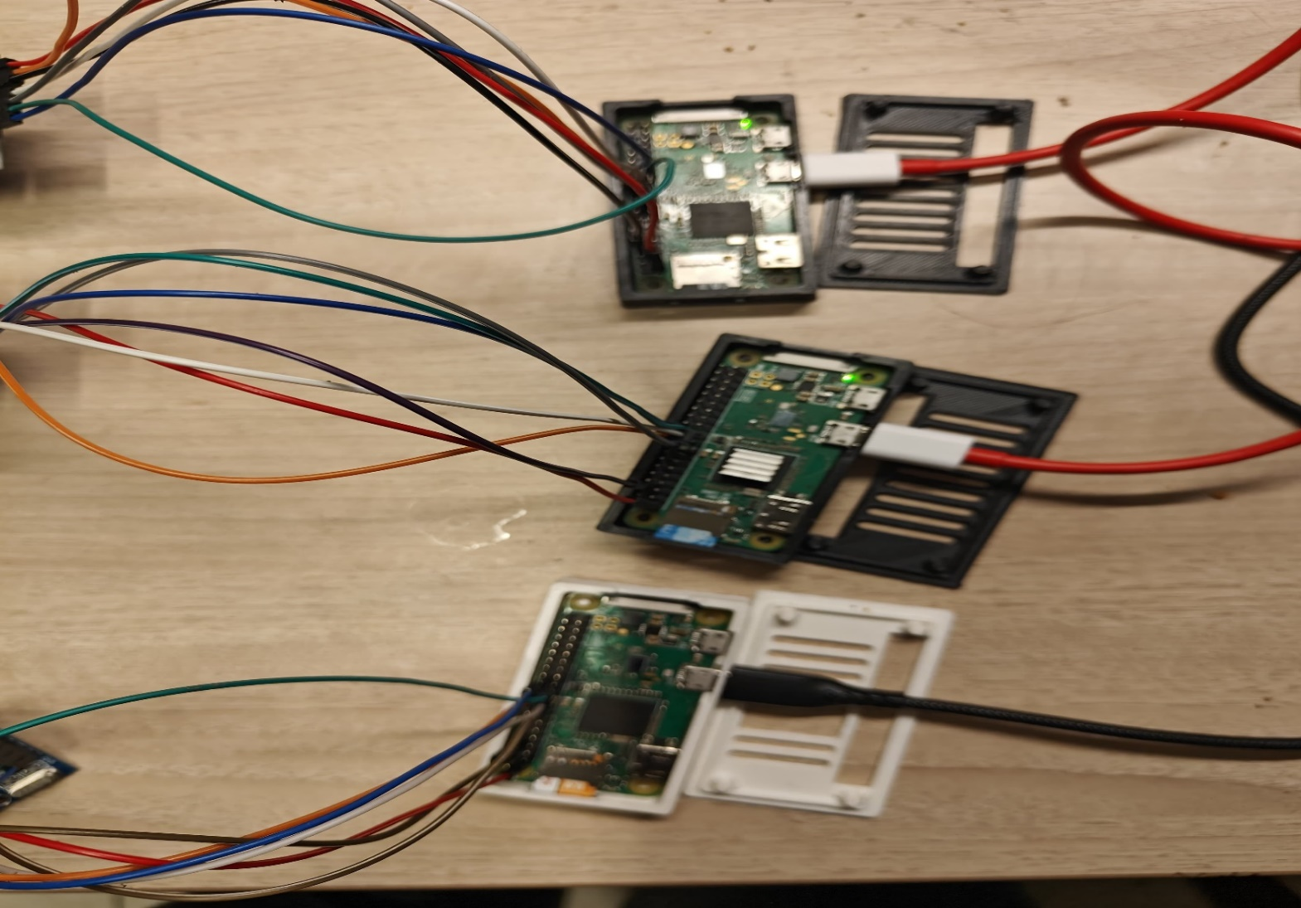

Figure 6.4.1: Showing the hardware circuits of the RFID system.

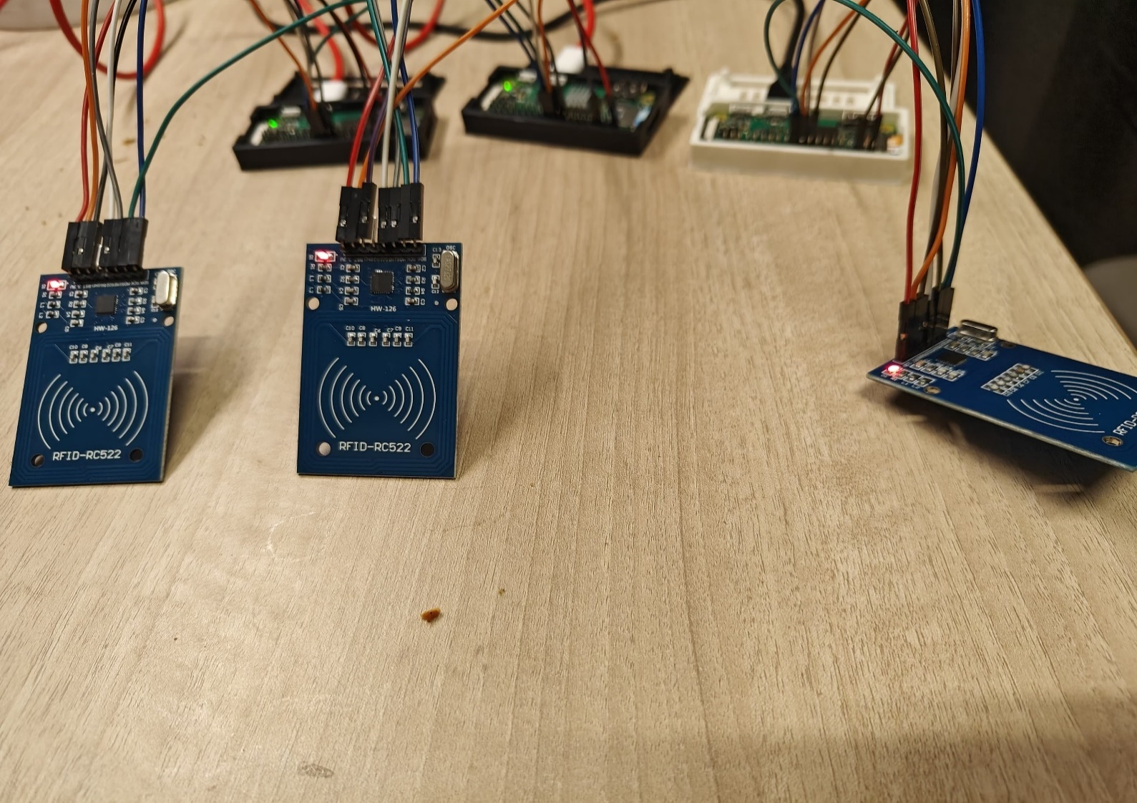Figure 6.4.2: Three raspberry pi zero w circuits depicting the attendance tracking, payments and access control.

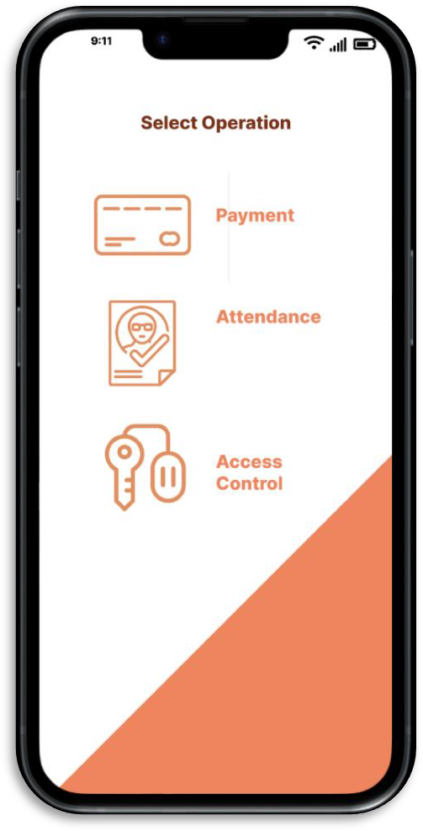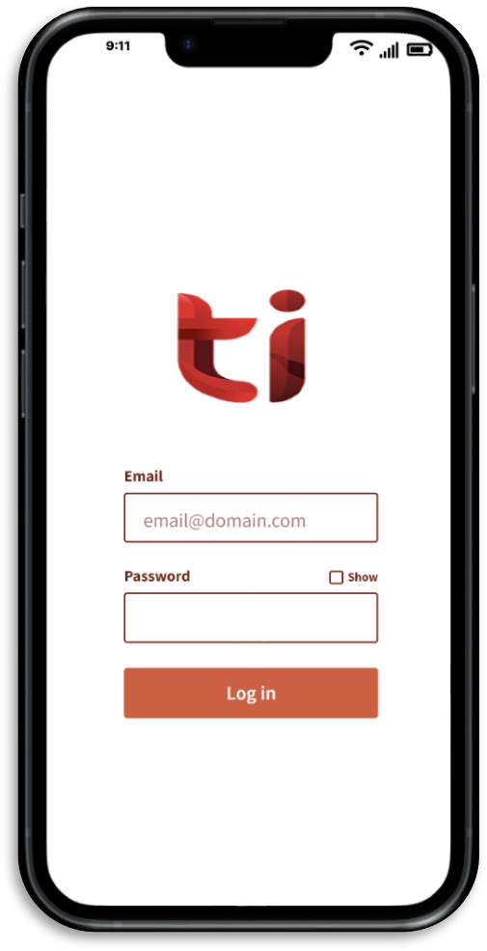

Figure 6.4.3: The Login Page

Figure 6.4.4: Select Operation

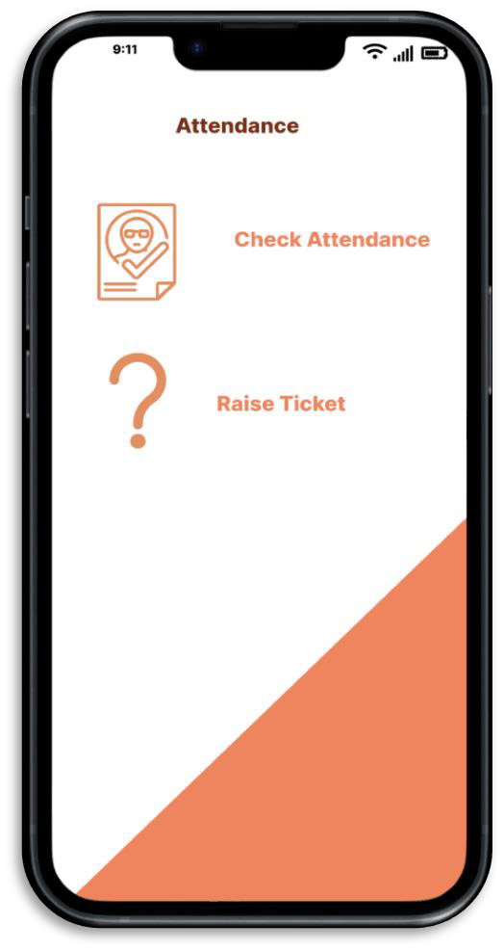

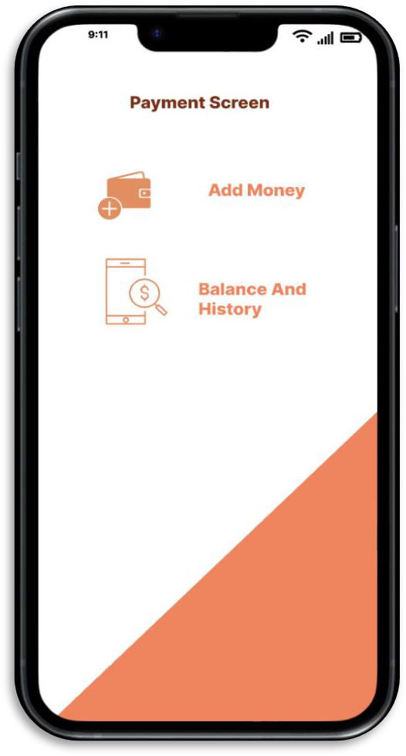

Figure 6.4.5: The Attendance Page

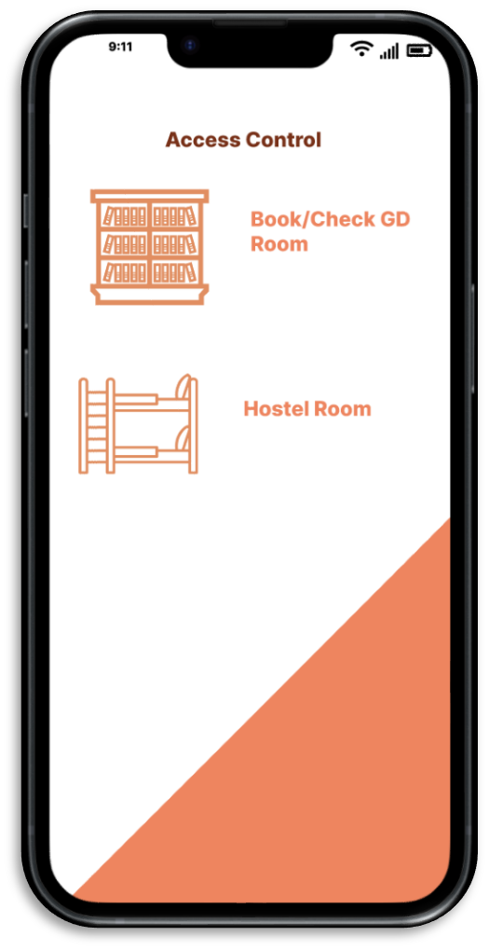

Figure 6.4.6: The Payment Screen

Figure 6.4.7: The Access Control Page

**5.4 Testing Process**

Validation of functionalities:

**5.4.1 Test Plan**

1. Attendance Tracking System:

* Validate the functionality of RFID card detection and reading.
* Verify the accuracy of attendance data recording in the centralized database.
* Confirm real-time updating of attendance records.
* Ensure secure and accurate monitoring of entry and exit events.

1. Payments System:

* Validate the functionality of cashless payments using RFID cards.
* Verify the accuracy and security of payment transactions.
* Confirm the seamless integration of payment data with the centralized database.
* Ensure students can view their payment history accurately.

1. Access Control:

* Validate the functionality of RFID card-based access verification.
* Verify the accuracy of access control permissions for authorized personnel.
* Confirm real-time access updates and secure access to restricted areas.
* Ensure administrators can manage access control permissions effectively.

1. Scope:
2. In-Scope:

* RFID card detection and reading for attendance tracking.
* Real-time updating of attendance records in the centralized database.
* Cashless payments using RFID cards.
* Integration of payment data with the centralized database.
* RFID card-based access verification for access control.
* Real-time access updates and access control permissions management.

1. Out-of-Scope:

* Hardware issues not related to RFID card detection.
* Network-related issues beyond the scope of the project.
* External factors affecting RFID signal strength.

**5.4.2 Features to be Tested**

1. Attendance Tracking System:

* RFID card detection and reading.
* Real-time updating of attendance records.

1. Payments System:

* Cashless payments using RFID cards.
* Integration of payment data with the centralized database.

1. Access Control:

* RFID card-based access verification.

**5.4.3 Test Strategy**

1. Unit Testing:

* Test RFID card detection and reading functionality.
* Validate the correctness of attendance data recording.

1. Integration Testing:

* Test integration between attendance tracking and the centralized database.
* Validate the integration of payment data with the centralized database.

1. System Testing:

* Conduct end-to-end testing of the attendance tracking system.
* Validate cashless payments and integration with the payments system.
* Test access control functionalities.

1. User Acceptance Testing (UAT):

* Involve end-users to validate the overall system functionality.
* Address user feedback and make necessary adjustments.

**5.4.4 Test Techniques**

1. Manual Testing: In our project, we are implementing manual testing, which involves direct human interaction to ensure that our attendance tracking system, payments system, and access control features function as expected. Our testers will actively engage with both the software and hardware components to validate various aspects of the system. As part of our testing strategy, we will manually test the RFID card detection process. This involves direct interaction with the RFID readers and cards to confirm accurate readings. Our goal is to ensure that the system reliably detects and reads RFID cards during attendance tracking.
2. Real-time Updating: To validate the real-time updating of attendance records, our testers will simulate different scenarios manually. This includes scenarios where students swipe their RFID cards, and the system should promptly update the attendance records. Through manual testing, we aim to confirm the seamless real-time functionality of our system.
3. Automated Testing: In our project, we are incorporating automated testing, leveraging testing tools and scripts to execute tests, compare results, and efficiently identify issues. This approach is particularly beneficial for handling repetitive and time-consuming tasks. The functionality of the code will be thoroughly verified through rigorous testing within a simulated environment. Outputs generated by diverse inputs will be closely monitored for accuracy and adherence to desired specifications.

As part of our continuous integration process, we will implement automated tests to ensure that any new updates or changes do not negatively impact the existing functionalities of our system. Automated regression testing will help maintain the stability and reliability of the overall system.

1. Performance Testing: Performance testing is a crucial aspect of our project, focusing on evaluating how well our attendance tracking system, payments system, and access control features perform under varying conditions, including load, stress, and scalability.

To assess the responsiveness of our system during attendance tracking, we will simulate heavy loads. This involves testing the system's ability to handle a significant number of concurrent interactions, ensuring that it remains responsive and efficient even under increased demand.

Our performance testing strategy includes evaluating how well the system scales with an increasing number of simultaneous users during payment transactions. This ensures that our system can effectively handle growth without compromising performance.

1. Usability Testing: Usability testing plays a vital role in assessing the user-friendliness and overall user experience of our system, with a specific focus on the software interface. We will actively evaluate the ease of use and effectiveness of our software interface through usability testing. Testers will interact with the interface to ensure that it is intuitive, user-friendly, and meets the expectations of our end-users.

Gathering feedback from end-users during usability testing is a key aspect of our project. By directly involving end-users in the testing process, we aim to identify areas for improvement in the design and functionality of our system, ensuring a positive user experience.

* + 1. **Test Cases**

The test cases in the Table 6 are created and performed on the RFID based system to test the functionalities of Attendance Tracking System, Payments and Acccess Control.

Table 6: Table showing the test cases used during the testing of the functionalities of the RFID system

|  |  |  |  |  |
| --- | --- | --- | --- | --- |
| Sr. No. | Test Case | Expected Output | Actual Output | Result |
| Test Case 101 | RFID Card Detection and Reading | * The RFID card is detected promptly. * The system registers the card accurately. * Data is updated in the centralized database without errors. | The card is read and registered properly | Successful |
| Test Case 102 | Real-time Attendance Updating | * Attendance records are updated in real-time. * Multiple swipes do not result in duplicate entries. * The system efficiently handles concurrent attendance updates. | The records are updated in real time and efficiently handles multiple entries. | Successful |
| Test Case 201 | Cashless Payments with RFID Cards | * The correct amount is deducted from the student's account. * Payment transactions are reflected accurately in the centralized database. * No discrepancies between the amount deducted and the recorded transaction. | The payments done by user reflects the change in user’s account correctly .real time updation of transactions and database gets updated accurately. | Successful, working on enhancing the security |
| Test Case 202 | Payment History Viewing | * The payment history section is accessible and displays relevant information. * The displayed payment history aligns with actual transactions. * The user interface is user-friendly and provides a clear overview of payment history. | Users successfully accessed the payment history section, where they found accurate transaction details displayed, and the user-friendly interface provided a clear overview of their payment history. | Successful |
| Test Case 301 | RFID-based Access Verification | * Access permissions are updated as per the modifications made. * The user experiences the expected changes in access. * Access logs accurately record and reflect the access control permissions management. | Permissions are promptly updated in accordance to the registered logs and anticipated changes in access. The access logs precisely record and reflect the management of access control permissions. | Successful |

**5.4.6 Test Results**

The successful testing of the mentioned test cases signifies the thorough validation and verification of our project's functionalities. Each test case, encompassing aspects such as RFID card detection, real-time attendance updating, cashless payments, payment history viewing, RFID-based access verification, and access control permissions management, has been meticulously executed, and the outcomes have met the expected criteria.

The project has transitioned into the presentable phase, indicating that all planned functionalities have undergone rigorous testing, and their successful implementation has been confirmed. The comprehensive testing process ensures that the attendance tracking system, payments system, and access control features are robust, reliable, and aligned with the project's objectives. The positive test results provide a solid foundation for presenting the project to stakeholders, showcasing its capabilities, and highlighting the successful achievement of the intended functionalities.

**5.5 Results and Discussions**

We tested our access control system on a group of 23 students. Analyzing the results, we created a confusion matrix to understand how accurately it differentiated authorized and unauthorized access attempts.

This matrix revealed promising results:

* Correctly granted access: The system accurately approved 12 authorized access attempts (True Positives or TP).
* Correctly denied access: It successfully blocked 8 unauthorized attempts (True Negatives or TN).
* False positives: Only 1 unauthorized attempt was mistakenly granted access (False Positive or FP).
* False negatives: In 2 cases, the system mistakenly denied authorized access (False Negative or FN).

To quantify the overall performance, we calculated the accuracy: (TP + TN) / total observations. This resulted in a 0.869 accuracy score, indicating a strong ability to distinguish authorized and unauthorized access attempts.

Table 7:Confusion Matrix for the Results on a group of 23 students

|  |  |  |
| --- | --- | --- |
| **Actual Access** | **Predicted Granted** | **Predicted Denied** |
| **Granted** | 12 (TP) | 2 (FN) |
| **Denied** | 1 (FP) | 8 (TN) |

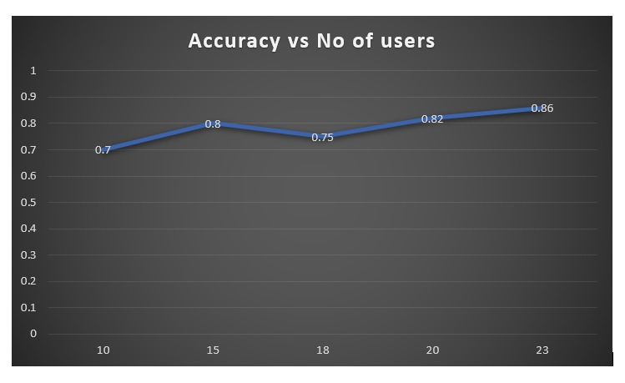

Figure 7: Shows the graph between the Accuracy calculated and the no of users

**5.6 Inferences Drawn**

"In reflection of our project's test results and performance evaluations, several inferences point towards both the successes achieved and opportunities for further enhancements:

* Successful Transformation and Identified Challenge: The project has successfully translated our initial idea into a working model, encompassing attendance tracking, payments, and access control through RFID technology. However, we acknowledge a challenge in achieving the desired accuracy for auto-scoring, one of our deliverables.
* Integration of Systems and Translation Accuracy: The integration of RFID technology for attendance tracking and payments has proven successful. Additionally, the integration of deep learning models for conversion and translation demonstrates reasonable accuracy in translating speeches and textual inputs, enhancing the overall versatility of our system.
* Potential for Performance Improvement: The testing phase has provided insights into areas for improvement. With the implementation of refined data processing algorithms and advanced deep learning models, we anticipate significant enhancements in system performance. Moreover, exploring advanced machine and deep learning algorithms holds promise for further improving accuracy.
* Scalability and Future Applications: The successful implementation of our project and the associated research results indicate a substantial scope for scalability. We envision the concept extending to diverse areas with similar applications, thereby broadening its impact and utility.

**5.7 Validation of Objectives**

Table 8: Table showing the list of objectives along with their status

|  |  |
| --- | --- |
| **Objectives** | **Status** |
| The complete build of RFID system with all the functionalities of Attendance Tracking, Payments and Access Control. | Successful |

**CONCLUSIONS AND FUTURE DIRECTIONS**

**6.1 Conclusions**

In conclusion, the RFID card system project successfully achieved its objectives of enhancing campus services, streamlining administrative processes, and bolstering security measures. Through the seamless integration of RFID cards, readers, attendance tracking, payment processing, access control, and harmonization with existing systems, the project created a transformative impact on the college campus. Students, faculty, and staff embraced the convenience, security, and efficiency offered by the RFID card system, making it an integral part of campus life. With positive feedback from the college community and the promise of continuous improvements, the RFID card system marked a promising leap forward in campus management and served as a foundation for future technological advancements within the institution.

**6.2 Environmental, Economic and Societal Benefits**

**Environmental Benefits:**

1. Paper Reduction: By implementing an automated attendance tracking system through RFID cards, the need for traditional paper-based attendance sheets is significantly reduced. This reduction in paper usage leads to decreased demand for raw materials and minimizes the energy and water consumption associated with paper production.
2. Energy Efficiency: RFID card readers are generally energy-efficient devices that consume minimal power during operation. Compared to traditional access control methods that rely on manual inputs or swipe cards, RFID technology consumes less energy, helping to conserve electricity and reduce greenhouse gas emissions.
3. Reduced E-Waste: RFID cards have a longer lifespan compared to traditional swipe cards or magnetic strip cards. This extended durability means that fewer cards need to be replaced or discarded, resulting in reduced electronic waste (e-waste) generation. Paper disposal of RFID cards at the end of their life cycle can also ensure their recycling or responsible disposal, further mitigating environmental impact.
4. Resource Conservation: With the RFID card system enabling cashless transactions, there is a reduced need for producing and handling paper currency. This leads to conservation of natural resources used in currency production, such as cotton or paper fibers as well as reducing the energy-intensive processes involved in minting coins or printing banknotes.
5. Carbon Footprint Reduction: By streamlining administrative processes and enhancing efficiency, the RFID card system can contribute to reducing the college's overall carbon footprint. Efficiencies gained in attendance tracking, access control, and payment processing translate to optimized operations and reduced energy consumption.
6. Promoting Sustainability Culture: Introducing an advanced RFID card system demonstrates the college's commitment to sustainability and environmental responsibility. Such projects can inspire students, faculty, and staff to adopt eco-friendly practices in other aspects of campus life, creating a culture of sustainability.

**Economic Benefits:**

1. Operational Cost Savings: Automated attendance tracking and access control can lead to significant cost savings by reducing the need for manual record-keeping and administrative staff. This contributes to overall operational efficiency.
2. Increased Efficiency in Financial Transactions: The RFID card system facilitates cashless transactions on campus, streamlining financial processes. This efficiency can lead to reduced transaction costs and better financial management for the college.
3. Optimized Resource Allocation: Accurate attendance data enables the college to better allocate resources, such as classroom space, faculty hours, and support services. This optimization can lead to cost savings and improved resource utilization.
4. Potential for Revenue Generation: The RFID card system, if integrated with other applications like campus events or loyalty programs, has the potential to generate additional revenue streams for the college through partnerships or sponsored initiatives.
5. Competitive Advantage: Embracing advanced technology and implementing systems that enhance overall campus functionality can give the college a competitive advantage. It can attract students and faculty members seeking a modern and efficient learning environment.
6. Long-Term Cost Benefits: While there may be an initial investment in implementing the RFID card system, the long-term cost benefits, including reduced operational costs and improved resource management, contribute to the economic sustainability of the project.

**Societal Benefits:**

1. Enhanced Security: The RFID card system improves overall campus security by providing a reliable and efficient means of access control. This ensures that only authorized individuals can enter specific areas, contributing to a safer campus environment.
2. Time Efficiency: Automated attendance tracking through RFID cards saves time for both students and faculty. This efficient process allows for more productive use of class time and reduces the administrative burden associated with manual attendance taking.
3. Convenience for Users: RFID cards offer a convenient and user-friendly way for students and staff to access various services on campus, such as attendance tracking, library access, and cashless transactions. This convenience enhances the overall user experience.
4. Data Accuracy and Transparency: The system provides accurate and real-time data on attendance and access, promoting transparency in administrative processes. This can lead to a fairer and more accountable environment within the college.
5. Promotion of Technological Literacy: Implementing advanced technology like RFID cards promotes technological literacy among students and staff. It prepares individuals for the increasingly digital and automated nature of the modern workforce.
6. Reduced Fraud and Identity Theft: The use of RFID technology enhances security against fraud and identity theft. The unique identifiers on RFID cards make it difficult for unauthorized individuals to gain access or impersonate others.

**6.3 Reflections**

RFID-based campus services system signifies a transformative blend of cutting-edge technology and practical applications in the academic landscape. Departing from conventional methods, the adoption of RFID technology with advanced encryption and authentication protocols ensures secure and efficient campus service management.

This segment-wise analysis provides valuable insights into the system's adaptability and accuracy, capturing nuanced aspects of campus service management. The project's success lies in its granular approach, leveraging RFID technology to streamline attendance, payment processing, and access control in real-time.

In conclusion, our project is a testament to the successful convergence of innovative technologies, offering an efficient and accurate solution for optimizing campus services. This achievement not only introduces technological advancements but also lays the groundwork for future innovations in RFID-based systems within educational institutions

**6.4 Future Work**

Here is the future work plan for the RFID card system project that should focus on continuous improvement, scalability, and expanding the system's capabilities to meet evolving needs:

1. User Feedback and Evaluation: Gather feedback from users, including students, faculty, and staff, to identify areas for improvement and understand their experiences with the RFID card system. Use this feedback to address any usability issues.
2. Technology Upgrades: Stay abreast of technological advancements in RFID and related fields. Consider upgrading the RFID card and reader technology to newer, more secure, and efficient versions. Explore options like contactless and multi-functional smart cards that can integrate additional features or functionalities.
3. Mobile App Integration: Develop a mobile application that complements the RFID card system. The app could allow users to check their account balances, transaction history, attendance records, and access permissions on their smartphones. Additionally, explore options for mobile-based access control using NFC or Bluetooth technology.
4. Sustainability Initiatives: Continue to promote sustainability by encouraging users to participate in eco-friendly practices. Introduce features that incentivize eco-conscious behaviors, who actively contribute to reducing their environmental impact using the RFID card system.
5. Data Analytics and Reporting: Implement robust data analytics capabilities to gain insights into user behavior, resource usage, and system performance. Use these insights to make data-driven decisions for further optimization, resource allocation, and identifying potential areas for efficiency gains.
6. Enhanced Security Measures: Continuously review and enhance the security measures of the RFID card system to protect against evolving cybersecurity threats. Regularly conduct security audits and penetration testing to identify vulnerabilities and implement necessary safeguards.
7. Campus-wide Expansion: Consider expanding the RFID card system's coverage to include more campus facilities and services. This might involve extending access control to additional areas or integrating the RFID card system with external facilities used by the college community.
8. Collaboration with External Partners: Collaborate with external partners, such as local businesses or service providers, to explore opportunities for extending the RFID card system's functionality beyond the campus.
9. Long-term Sustainability Plan: Develop a long-term sustainability plan for the RFID card system, including regular maintenance, hardware replacements, and software updates. Consider budget allocation and resource planning to ensure the system's continuous operation and growth.
10. Training and Support Improvements: Continuously enhance training materials and support resources for new users and staff. Conduct periodic workshops and refresher sessions to keep users informed about system updates and best practices.
11. Regulatory Compliance: Stay updated with relevant regulations and compliance standards related to data privacy and security. Ensure that the RFID card system adheres to all necessary legal requirements and industry standards.

By following this future work plan, the RFID card system will continue to be an essential asset for the college, improving campus life, enhancing security, and promoting sustainability while adapting to changing technological landscapes and user needs.

**PROJECT METRICS**

**7.1 Challenges Faced**

During the implementation of our RFID-based card system project, we encountered a series of challenges that necessitated innovative thinking and optimization strategies. One significant challenge revolved around the building of the hardware model to achieve the desired functionalities, particularly in the domain of attendance tracking and real-time updating of attendance records. Crafting a reliable and efficient hardware model required a meticulous understanding of RFID technology, demanding creative problem-solving to ensure seamless communication between RFID-enabled cards and readers.

Integrating the attendance tracking system with access control posed another set of challenges. Ensuring that access to various campus facilities was both secure and streamlined required careful consideration of system architecture and data processing. This challenge underscored the need for innovative solutions to maintain the integrity of the system while providing a convenient experience for users.

Accurate processing of financial transactions, including real-time updating of balances and payment histories, introduced complexities that demanded optimized functionalities. Addressing these challenges involved a careful balance between security measures, such as encryption and authentication protocols, and the need for swift and accurate transaction processing. The integration of financial components into the RFID system highlighted the importance of optimizing processes to enhance both speed and accuracy.

Throughout these challenges, the project team embraced the need for innovative thinking to overcome obstacles and optimize functionalities. The iterative development process involved continuous refinement of the hardware model, software algorithms, and integration protocols to achieve a seamless and efficient RFID-based card system. The journey underscored the importance of balancing innovation with optimization to create a robust solution that meets the diverse needs of attendance tracking, access control, and financial transactions in a real-time and interconnected campus environment.

**7.2 Relevant Subjects**

1. Software Engineering: Software engineering is instrumental in crafting clear and comprehensive documentation for the report file. It guides the creation of systematic testing strategies and techniques, ensuring the RFID-based card system's robustness. Additionally, software engineering principles play a crucial role in drawing Unified Modelling Language (UML) diagrams, providing a visual representation of the system's architecture and interactions. This integrated approach ensures effective communication, reliability, and success throughout the project lifecycle.
2. Computer architecture and organization: Its principles are essential for understanding how the RFID-based card system interacts with the underlying hardware. This includes considerations for the design of the RFID reader infrastructure, data storage mechanisms, and the overall organization of the computing system that processes the RFID data. Optimizing the system's performance and ensuring compatibility with different hardware components fall under this domain.
3. Database Management System (DBMS): The concepts are crucial for handling and managing data related to attendance records, payment transactions, and access control. The project involves creating and maintaining databases to store information securely, and DBMS principles guide tasks such as data modeling, normalization, and querying to ensure efficient data retrieval and manipulation.
4. Microprocessor-based systems design: It is pertinent to the implementation of RFID technology. Understanding how microcontrollers interact with RFID readers, process data, and execute commands is fundamental. This subject contributes to the design of the embedded systems that enable seamless communication between RFID-enabled cards and the system infrastructure.
5. Electronic engineering: The concepts come into play in the design and integration of RFID technology. This includes understanding the principles behind radio frequency communication, signal processing, and electronic components used in RFID readers and cards. Electronic engineering knowledge ensures the reliability and efficiency of the RFID-based system.
6. Network programming: It is crucial for establishing the wireless communication framework required for the RFID-based card system. Concepts such as network protocols, data transmission, and security measures are applied to enable communication between RFID readers, the central system, and other components. Network programming ensures seamless connectivity and data exchange.
7. Android development: It is relevant if the project involves a mobile application for users. If the RFID-based card system includes a mobile app for tasks like accessing attendance records or making payments, Android development concepts, such as user interface design, data storage on mobile devices, and integration with the RFID system, are crucial for a seamless user experience.

**7.3 Interdisciplinary Knowledge Sharing**

Our project, the "RFID-based Campus Services System," represents a convergence of expertise from various disciplines, contributing significantly to its successful development. Given the multifaceted nature of the project, interdisciplinary knowledge sharing played a pivotal role in harnessing diverse insights.

The project draws extensively from subjects like Software Engineering, Database Management System, Computer Architecture, and Networking. A profound understanding of software engineering principles guided the project's structure, ensuring a systematic approach to development, testing, and maintenance. Knowledge gleaned from database management systems facilitated informed decisions on data storage and retrieval mechanisms.

Computer architecture concepts were instrumental in designing the hardware components of the RFID system, ensuring efficient communication between RFID readers and cards. Networking principles guided the establishment of a secure and seamless wireless communication framework for the RFID-enabled cards. In addition, the project involved the application of Electronic Engineering principles in the integration of RFID technology. Understanding the intricacies of radio frequency communication and signal processing was vital for the successful deployment of the RFID-based card system.

This interdisciplinary collaboration allowed us to leverage a rich tapestry of knowledge, ensuring the development of a holistic and robust RFID-based campus services system. The fusion of concepts from various disciplines not only facilitated problem-solving but also enriched our understanding of how different domains can harmoniously contribute to the success of a complex engineering project.

* 1. **Peer Assessment Matrix**

Table 9: Peer Assessment Matrix showing a systematic framework for evaluating and comparing individual contributions within the group

|  |  |  |  |  |  |  |
| --- | --- | --- | --- | --- | --- | --- |
|  | | **Evaluation Of** | | | | |
| **MANVI** | **NAMAY** | **PRAJWAL** | **SPARSH** | **SANYA** |
| **Evaluation By** | **MANVI** | **5** | **5** | **5** | **5** | **5** |
| **NAMAY** | **5** | **5** | **5** | **5** | **5** |
| **PRAJWAL** | **5** | **5** | **5** | **5** | **5** |
| **SPARSH** | **5** | **5** | **5** | **5** | **5** |
| **SANYA** | **5** | **5** | **5** | **5** | **5** |

* 1. **Role Playing and Work Schedule**

Table 10: Table Role Playing for the Project

|  |  |  |
| --- | --- | --- |
| **Sr. No.** | **Team Members** | **Roles** |
| 1. | MANVI VERMA | Documentation, Testing, Hardware Assembling. |
| 2. | NAMAY GUPTA | Documentation, Hardware Assembling, Coding. |
| 3. | SPARSH LAMBA | Hardware Assembling, Front-end, Coding. |
| 4. | PRAJWAL SADOTRA | Research Analysis, Front-end, UI/UX Design. |
| 5. | SANYA AGGARWAL | Research Analysis, UI/UX Design, Testing. |



Figure 8: Work Schedule for the project

* 1. **Student Outcomes Description and Performance Indicators**

Table 11: The student outcome description table outlining the expected educational achievements and competencies

|  |  |  |
| --- | --- | --- |
| **SO** | **Student Outcomes Description** | **Outcome** |
| 1.1 | Apply engineering, science, and mathematics body of knowledge to obtain analytical, numerical, and statistical solutions to solve engineering problems. | Apply Engineering, Science, and Mathematics Knowledge: The project extensively applies engineering, science, and mathematics knowledge in designing and implementing the RFID-based system. This involves the application of computer engineering principles, including RFID technology, network programming, and software engineering methodologies. |
| 2.1 | Ability to analyze the economic trade-offs in computing systems. | Analyze Economic Trade-offs: Economic trade-offs in computing systems, such as the selection of RFID technology and the choice of a specific database like MongoDB, are carefully analyzed to optimize system performance and cost-effectiveness. |
| 3.1 | Prepare and present variety of documents such as project or laboratory reports according to computing standards and protocols. | Effective communication is demonstrated in the collaborative and logical manner in which the team discusses and solves computational domain problems related to attendance tracking, payment processing, and access control. |
| 3.2 | Able to communicate effectively with peers in well organized and logical manner using adequate technical knowledge to solve computational domain problems and issues. | Effective communication is demonstrated in the collaborative and logical manner in which the team discusses and solves computational domain problems related to attendance tracking, payment processing, and access control. |
| 4.1 | Evaluate computational engineering solutions considering environmental, societal, and economic contexts. | The project involves the evaluation of computational engineering solutions, considering environmental, societal, and economic contexts, to ensure the RFID-based system meets the established objectives and goals. |
| 5.1 | Able to plan, share and execute task responsibilities to function effectively by creating collaborative and inclusive environment in a team. | Effective planning, task-sharing, and execution of responsibilities within the team create a collaborative and inclusive environment, fostering efficient development of the RFID-based system. |
| 6.1 | Ability to perform experimentations and further analyze the obtained results. | The team engages in experimentations, especially in testing RFID system to test the functionalities, and analyzes the obtained results to refine and optimize system functionalities |
| 7.1 | Able to explore and utilize resources to enhance self-learning. | Throughout the project, team members actively explore and utilize resources beyond standard coursework, enhancing self-learning in areas such as RFID technology and software development for campus services. |

**7.7 Brief Analytical Assessment**

**Q1. What sources of information did the project team explore to identify potential challenges in implementing the RFID-based card system on campus?**

**Ans:** To identify potential challenges in implementing the RFID-based card system on campus, our project team extensively explored academic literature on RFID technology and engaged in discussions with students and teachers to gain insights into potential hurdles and solutions in similar implementations.

**Q2. What analytical, computational, and/or experimental methods did the project team employ to devise solutions to the identified problems in implementing the RFID-based card system?**

**Ans:** In addressing the identified challenges, our project team employed a combination of analytical, computational, and experimental methods. We conducted feasibility studies, simulations, and prototype testing to iteratively refine and enhance the RFID-based card system's design and functionality.

**Q3. Did the project demand demonstration of knowledge of fundamentals, scientific and engineering principles? If yes, how did you apply?**

**Ans:** Yes, the project demanded a demonstration of knowledge in software engineering, RFID technology, and related engineering principles. We focused on applying software engineering methodologies to design the system architecture, implementing RFID communication protocols, and ensuring the security and reliability of the overall solution.

**Q4. How did the project team coordinate responsibilities and communicate schedule information to address design and implementation dependencies in the development of the RFID-based card system?**

**Ans:** Coordination of responsibilities and schedule information within the project team was facilitated through regular team meetings, collaborative project management tools, and transparent communication channels. Each team member's expertise was utilized effectively to address design and implementation dependencies.

**Q5. What resources were utilized by the project team to acquire knowledge and skills not covered in the standard coursework, specifically related to the implementation of RFID technology and software development for campus services?**

**Ans:** To acquire knowledge and skills beyond standard coursework, our project team leveraged online tutorials, industry publications, and collaborative learning sessions. We also engaged in hands-on experimentation with RFID technology and explored software development resources specific to campus service applications.

**Q6. Does the project make you appreciate the need to solve problems in real life using engineering and could the project development make you proficient with software development tools and environments?**

**Ans:** Developing the RFID-based card system significantly enhanced my appreciation for solving real-life problems using engineering principles. It provided a practical application of software engineering and RFID technology, contributing to a deeper understanding of their real-world implications. Additionally, the project significantly improved my proficiency in utilizing software development tools and environments tailored to the implementation of hardware models and electronic circuits.

**APPENDIX A: REFERENCES**

[1] M. O. Adebiyi, R. O. Ogundokun, A. L. Nathus, and E. A. Adeniyi, "Smart transit payment for university campus transportation using RFID card system," International Journal of Electrical and Computer Engineering, vol. 11, no. 5, pp. 4353-4357, 2021.

[2] H. T. S. ALRikabi, A. H. M. Alaidi, and F. T. Abed, "Attendance System Design And Implementation Based On Radio Frequency Identification (RFID) And Arduino," Journal of Advanced Research in Dynamical Control Systems, vol. 10, no. 4, pp. 1342-1347, 2018.

[3] R. M. Woo-Garcia, U. H. Lomeli-Dorantes, F. Lopez-Huerta, A. L. Herrera-May, and J. Martinez-Castillo, "Design and implementation of a system access control by RFID," in 2016 IEEE International Engineering Summit (IE-Summit), pp. 1-4, 2016.

[4] K. K. Maheshkar and D. G. Agrawal, "Campus Access Management System via RFID," International Journal of Innovative Technology and Exploring Engineering, vol. 4, no. 8, 2015.

[5] U. Farooq, M. ul Hasan, M. Amar, A. Hanif, and M. U. Asad, "RFID based security and access control system," International Journal of Engineering and Technology, vol. 6, no. 4, pp. 309-316, 2014.

[6] I. Lacmanovic, B. Radulovic, and D. Lacmanovic, "Contactless payment systems based on RFID technology," in 2010 33rd International Convention MIPRO, pp. 1114-1119, 2010.

[7] V. V. Vaidyanathan, M. R. Varanasi, E. Kougianos, S. Wang, and H. Raman, "RFID student educational experiences at the UNT college of engineering: A sequential approach to creating a project-based RFID course," IEEE Transactions on Education, vol. 52, no. 3, pp. 404-412, 2009.

[8] M. Y. Sabri, M. A. Aziz, M. M. Shah, and M. F. Abd Kadir, "Smart attendance system by using RFID," in 2007 Asia -Pacific Conference on Applied Electromagnetics (APEEM '07), pp. 1-4, 2007.

[9] R. Want, "An introduction to RFID technology," IEEE Pervasive Computing, vol. 5, no. 1, pp. 25-33, 2006.

**APPENDIX B: PLAGIARISM REPORT**



